1. **Array Operation (Insertion, Deletion, Sorting, Merging)**

**Program:**

#include <stdio.h>

void display(int arr[], int n) {

printf("Array: ");

for (int i = 0; i < n; i++) {

printf("%d ", arr[i]);

}

printf("\n");

}

void insert(int arr[], int *n, int element, int position) {

if (*n >= 100) {

printf("Array is full. Cannot insert.\n");

return;

}

if (position < 0 || position > *n) {

printf("Invalid position for insertion.\n");

return;

}

for (int i = *n; i > position; i--) {

arr[i] = arr[i - 1];

}

arr[position] = element;

(*n)++;

}

void deleteElement(int arr[], int *n, int position) {

if (*n <= 0) {

printf("Array is empty. Cannot delete.\n");

return;

}

if (position < 0 || position >= *n) {

printf("Invalid position for deletion.\n");

return;

}

for (int i = position; i < *n - 1; i++) {

arr[i] = arr[i + 1];

}

(*n)--;

}

void merge(int arr1[], int n1, int arr2[], int n2, int result[]) {

int i = 0, j = 0, k = 0;

while (i < n1 && j < n2) {

if (arr1[i] < arr2[j]) {

result[k++] = arr1[i++];

} else {

result[k++] = arr2[j++];

}

}

while (i < n1) {

result[k++] = arr1[i++];

}

while (j < n2) {

result[k++] = arr2[j++];

}

}

int main() {

int arr1[100], arr2[100], merged[200];

int n1, n2;

printf("Enter the size of the first array: ");

scanf("%d", &n1);

printf("Enter elements for the first array:\n");

for (int i = 0; i < n1; i++) {

scanf("%d", &arr1[i]);

}

printf("Enter the size of the second array: ");

scanf("%d", &n2);

printf("Enter elements for the second array:\n");

for (int i = 0; i < n2; i++) {

scanf("%d", &arr2[i]);

}

merge(arr1, n1, arr2, n2, merged);

int mergedSize = n1 + n2;

for (int i = 0; i < mergedSize - 1; i++) {

for (int j = 0; j < mergedSize - i - 1; j++) {

if (merged[j] > merged[j + 1]) {

int temp = merged[j];

merged[j] = merged[j + 1];

merged[j + 1] = temp;

}

}

}

printf("Merged and Sorted Array:\n");

display(merged, mergedSize);

int choice;

int element, position;

while (1) {

printf("\nArray Operations:\n");

printf("1. Insertion\n");

printf("2. Deletion\n");

printf("3. Display Merged Array\n");

printf("4. Exit\n");

printf("Enter your choice: ");

scanf("%d", &choice);

switch (choice) {

case 1:

printf("Enter the element to insert: ");

scanf("%d", &element);

printf("Enter the position for insertion: ");

scanf("%d", &position);

insert(merged, &mergedSize, element, position);

printf("Element inserted successfully.\n");

break;

case 2:

printf("Enter the position for deletion: ");

scanf("%d", &position);

deleteElement(merged, &mergedSize, position);

printf("Element deleted successfully.\n");

break;

case 3:

display(merged, mergedSize);

break;

case 4:

return 0;

default:

printf("Invalid choice. Please try again.\n");

}

}

return 0;

}

**Output:**

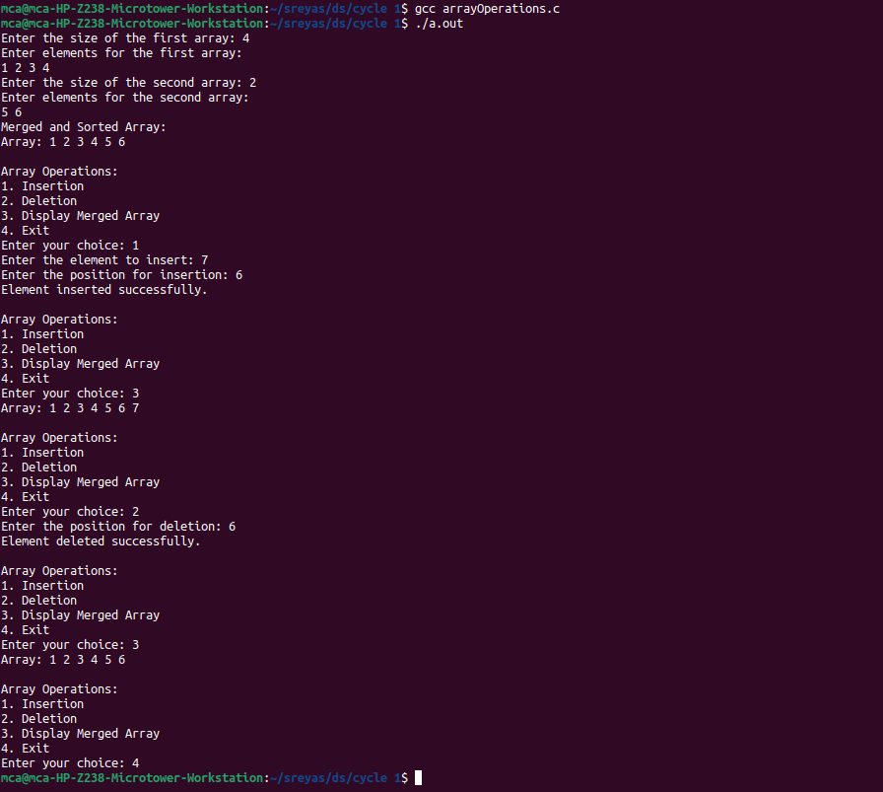

1. **Searching an array element ( Linear Search, Binary Search)**

**Program:**

#include <stdio.h>

// This function is used for getting the search key

int getKey(){

int key;

printf("enter the key to search : ");

scanf("%d", &key);

return key;

}

// function to perform linear search

void linearSearch(int n) {

int arr[50], flag=0;

printf("Enter elements of the array :\n");

for (int i = 0; i < n; i++) {

scanf("%d", &arr[i]);

}

int key = getKey();

int i=0;

for (i = 0; i < n; i++) {

if (arr[i] == key) {

flag = 1;

break;

}

}

if(flag==1){

printf("element found at location %d.\n", i+1);

} else {

printf("element not found.\n");

}

}

// function to perform binary search

void binarySearch(int n) {

int left = 0, arr[50];

int right = n - 1;

printf("Enter elements of the array in ascending order:\n");

for (int i = 0; i < n; i++) {

scanf("%d", &arr[i]);

}

int key = getKey();

int flag = 0;

int mid = 0;

while (left <= right) {

mid = left + (right - left) / 2;

if (arr[mid] == key) {

flag = 1;

break;

} else if (arr[mid] < key) {

left = mid + 1;

} else {

right = mid - 1;

}

}

if(flag==1){

printf("element found at location %d.\n", mid+1);

} else {

printf("element not found.\n");

}

}

int main() {

int arr[100];

int n;

printf("Enter the size of the array: ");

scanf("%d", &n);

int opt;

while(1){

printf("1.binary search\n2.linear search\n3.exit\nEnter the operation : ");

scanf("%d", &opt);

switch(opt){

case 1: binarySearch(n);

break;

case 2: linearSearch(n);

break;

case 3: return 1;

default: printf("invalid input.\n");

}

}

return 1;

}

**Output:**

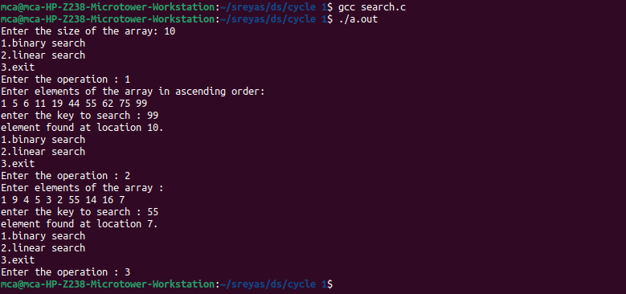

1. **Matrix Operations ( Addition, Multiplication, Transpose)**

**Program:**

#include <stdio.h>

void displayMatrix(int mat[][100], int rows, int cols) {

printf("Matrix:\n");

for (int i = 0; i < rows; i++) {

for (int j = 0; j < cols; j++) {

printf("%d\t", mat[i][j]);

}

printf("\n");

}

}

void addMatrices(int mat1[][100], int mat2[][100], int result[][100], int rows, int cols) {

for (int i = 0; i < rows; i++) {

for (int j = 0; j < cols; j++) {

result[i][j] = mat1[i][j] + mat2[i][j];

}

}

}

void multiplyMatrices(int mat1[][100], int rows1, int cols1, int mat2[][100], int cols2, int result[][100]) {

for (int i = 0; i < rows1; i++) {

for (int j = 0; j < cols2; j++) {

result[i][j] = 0;

for (int k = 0; k < cols1; k++) {

result[i][j] += mat1[i][k] * mat2[k][j];

}

}

}

}

void transposeMatrix(int mat[][100], int rows, int cols, int result[][100]) {

for (int i = 0; i < rows; i++) {

for (int j = 0; j < cols; j++) {

result[j][i] = mat[i][j];

}

}

}

void main() {

int mat1[100][100], mat2[100][100], result[100][100];

int rows1, cols1, rows2, cols2;

printf("Enter the number of rows for the first matrix: ");

scanf("%d", &rows1);

printf("Enter the number of columns for the first matrix: ");

scanf("%d", &cols1);

printf("Enter elements for the first matrix:\n");

for (int i = 0; i < rows1; i++) {

for (int j = 0; j < cols1; j++) {

scanf("%d", &mat1[i][j]);

}

}

printf("Enter the number of rows for the second matrix: ");

scanf("%d", &rows2);

printf("Enter the number of columns for the second matrix: ");

scanf("%d", &cols2);

printf("Enter elements for the second matrix:\n");

for (int i = 0; i < rows2; i++) {

for (int j = 0; j < cols2; j++) {

scanf("%d", &mat2[i][j]);

}

}

if (rows1 == rows2 && cols1 == cols2) {

addMatrices(mat1, mat2, result, rows1, cols1);

printf("Matrix Addition Result:\n");

displayMatrix(result, rows1, cols1);

} else {

printf("Matrix addition is not possible. Matrices must have the same dimensions for addition.\n");

}

if (cols1 != rows2) {

printf("Matrix multiplication is not possible. Number of columns in the first matrix must be equal to the number of rows in the second matrix.\n");

} else {

multiplyMatrices(mat1, rows1, cols1, mat2, cols2, result);

printf("Matrix Multiplication Result:\n");

displayMatrix(result, rows1, cols2);

}

transposeMatrix(mat1, rows1, cols1, result);

printf("Transpose of the First Matrix:\n");

displayMatrix(result, cols1, rows1);

transposeMatrix(mat2, rows2, cols2, result);

printf("Transpose of the Second Matrix:\n");

displayMatrix(result, cols2, rows2);

}

**Output:**

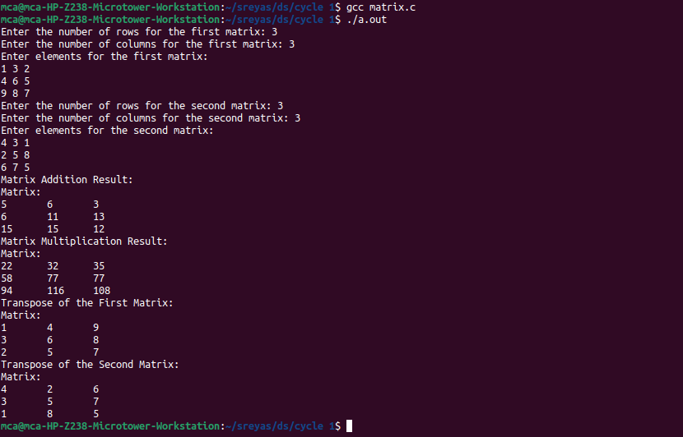

1. **Using Structure, add two distances in the inch-feet system.**

**Program:**

#include <stdio.h>

struct Distance {

int feet;

int inches;

}d1, d2, result;

void addDistances() {

result.inches = d1.inches + d2.inches;

result.feet = result.inches >= 12 ? d1.feet + d2.feet + result.inches/12 : d1.feet + d2.feet;

result.inches %= 12;

}

void main() {

printf("Enter the first distance:\n");

printf("Feet: ");

scanf("%d", &d1.feet);

printf("Inches: ");

scanf("%d", &d1.inches);

printf("Enter the second distance:\n");

printf("Feet: ");

scanf("%d", &d2.feet);

printf("Inches: ");

scanf("%d", &d2.inches);

addDistances();

printf("Sum of the distances: %d feet %d inches\n", result.feet, result.inches);

}

**Output:**

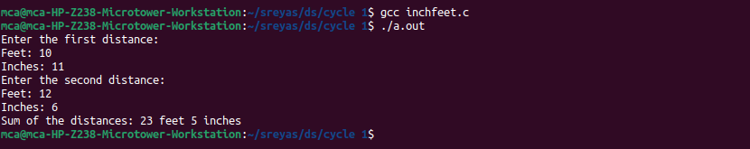

1. **Implement Stack Operations**

**Program:**

#include <stdio.h>

#include <stdlib.h>

int top=-1, stack[100], maxsize;

void caseCheck();

void push(){

int element;

printf("enter the element to read : ");

scanf("%d", &element);

if(top+1!=maxsize){

top++;

stack[top] = element;

} else {

printf("stack overflow\n");

}

caseCheck();

}

void pop(){

if(top == -1){

printf("stack is empty\n");

} else {

top--;

}

caseCheck();

}

void display(){

for(int i=0; i<=top; i++){

printf("%d \t", stack[i]);

}

caseCheck();

}

void peek(){

if(top == -1){

printf("stack is empty\n");

} else {

printf("last element is : %d\n", stack[top]);

}

caseCheck();

}

void isFull(){

if(top == maxsize-1){

printf("stack is full\n");

} else {

printf("stack is not full\n");

}

caseCheck();

}

void caseCheck(){

int option;

printf("\n1.push\n2.pop\n3.peek\n4.check if the stack is full\n5.display\n6.exit\nEnter the operation : ");

scanf("%d", &option);

switch(option){

case 1 : push();

break;

case 2 : pop();

break;

case 3 : peek();

break;

case 4 : isFull();

break;

case 5 : display();

break;

case 6 : exit(0);

break;

default : printf("enter a valid input");

}

}

void main(){

printf("enter the no.of elements : ");

scanf("%d", &maxsize);

caseCheck();

}

**Output:**

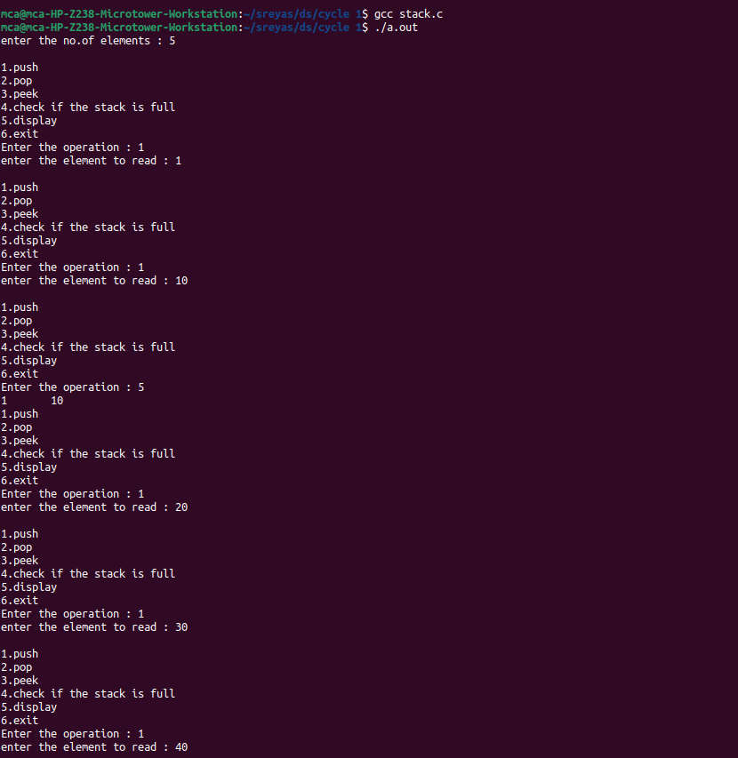

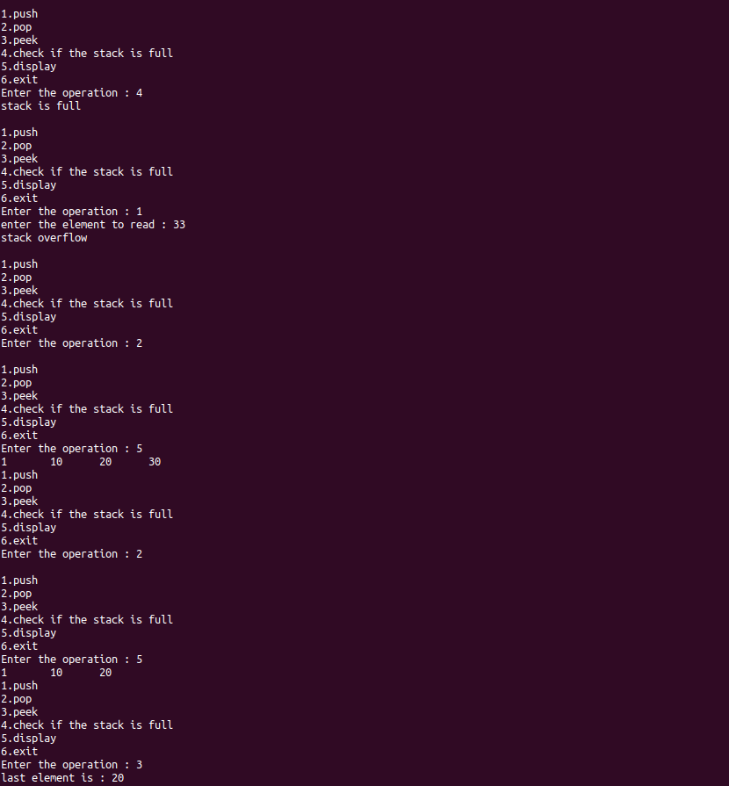

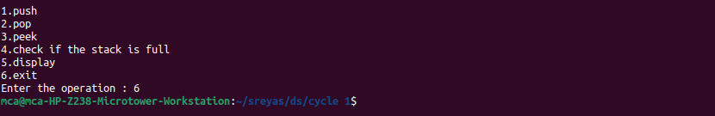

1. **String Operations ( Searching, Concatenation, Substring)**

**Program:**

#include <stdio.h>

#include <string.h>

int searchSubstring(char *str, char *subStr) {

char *p = strstr(str, subStr);

return (p) ? p - str : -1;

}

void concatenateStrings(char *str1, char *str2, char *result) {

strcpy(result, str1);

strcat(result, str2);

}

void extractSubstring(char *str, int start, int length, char *result) {

strncpy(result, str + start, length);

result[length] = '\0';

}

int main() {

char str1[100], str2[100], subStr[100], result[200];

int start, length;

printf("Enter the first string: ");

scanf("%s", str1);

printf("Enter the second string: ");

scanf("%s", str2);

printf("Enter the substring to check : ");

scanf("%s", subStr);

concatenateStrings(str1, str2, result);

printf("Concatenated string: %s\n", result);

int index = searchSubstring(result, subStr);

if (index != -1) {

printf("Substring found at position %d in the string.\n", index+1);

} else {

printf("Substring not found in the first string.\n");

}

concatenateStrings(str1, str2, result);

printf("Concatenated string: %s\n", result);

printf("Enter the starting index for substring extraction: ");

scanf("%d", &start);

printf("Enter the length of the substring to extract: ");

scanf("%d", &length);

extractSubstring(str1, start, length, result);

printf("Extracted substring: %s\n", result);

return 0;

}

**Output:**

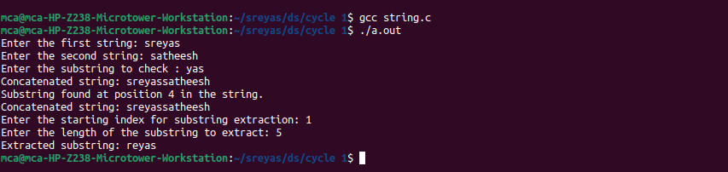

1. **Sorting an Array ( Bubble Sort, Selection Sort, Insertion Sort )**

**Program:**

#include <stdio.h>

void displayArray(int arr[], int size) {

for (int i = 0; i < size; i++) {

printf("%d ", arr[i]);

}

printf("\n");

}

void bubbleSort(int arr[], int size) {

for (int i = 0; i < size - 1; i++) {

for (int j = 0; j < size - i - 1; j++) {

if (arr[j] > arr[j + 1]) {

int temp = arr[j];

arr[j] = arr[j + 1];

arr[j + 1] = temp;

}

}

}

}

void selectionSort(int arr[], int size) {

int min, temp;

for (int i = 0; i < size - 1; i++) {

min = i;

for (int j = i + 1; j < size; j++) {

if (arr[j] < arr[min]) {

min = j;

}

}

temp = arr[i];

arr[i] = arr[min];

arr[min] = temp;

}

}

void insertionSort(int arr[], int size) {

int key, j;

for (int i = 1; i < size; i++) {

key = arr[i];

j = i - 1;

while (j >= 0 && arr[j] > key) {

arr[j + 1] = arr[j];

j = j - 1;

}

arr[j + 1] = key;

}

}

void main() {

int arr[100], size;

printf("Enter the number of elements in the array: ");

scanf("%d", &size);

printf("Enter the elements of the array:\n");

for (int i = 0; i < size; i++) {

scanf("%d", &arr[i]);

}

int bubbleSortedArr[100];

for (int i = 0; i < size; i++) bubbleSortedArr[i] = arr[i];

bubbleSort(bubbleSortedArr, size);

printf("Bubble Sort Result: ");

displayArray(bubbleSortedArr, size);

int selectionSortedArr[100];

for (int i = 0; i < size; i++) selectionSortedArr[i] = arr[i];

selectionSort(selectionSortedArr, size);

printf("Selection Sort Result: ");

displayArray(selectionSortedArr, size);

int insertionSortedArr[100];

for (int i = 0; i < size; i++) insertionSortedArr[i] = arr[i];

insertionSort(insertionSortedArr, size);

printf("Insertion Sort Result: ");

displayArray(insertionSortedArr, size);

}

**Output:**

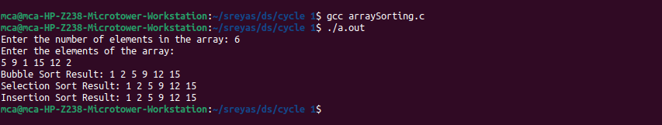

1. **Implement Queue operations (Insert, delete, display front & rear values)**

**Program:**

#include<stdio.h>

#define MAX 50

int q[20],choice,n,rear=-1,front=-1,x,i;

void insert(){

int item;

if (rear==MAX-1){

printf("Queue Overflow \n");

}else{

if (front==-1)

front=0;

printf("Inset the element in queue: ");

scanf("%d",&item);

rear=rear+1;

q[rear]=item;

}}

void delete(){

if(front==-1||front>rear){

printf("Queue Underflow \n");

return ;

}else{

printf("Element deleted from queue is : %d\n", q[front]);

front=front+1;

}}

void display(){

int i;

if (front==-1)

printf("Queue is empty \n");

else

{

printf("Queue is : ");

for (i=front;i<=rear;i++)

printf("%d ", q[i]);

printf("\nFront element is %d ", q[front]);

printf("\nRear element is %d ", q[rear]);

printf("\n");

}}

int main(){

while(choice != 4) {

printf("\nEnter the choice(1.Insert 2.Delete 3.Display 4.Exit): ");

scanf("%d",&choice);

switch(choice) {

case 1: {

insert();

break;

}

case 2: {

delete();

break;

}

case 3:{

display();

break;

}

case 4:{

printf("Exit\n");

break;

}

default:{

printf("Enter valid option");

}}}

return 0;

}

**Output:**

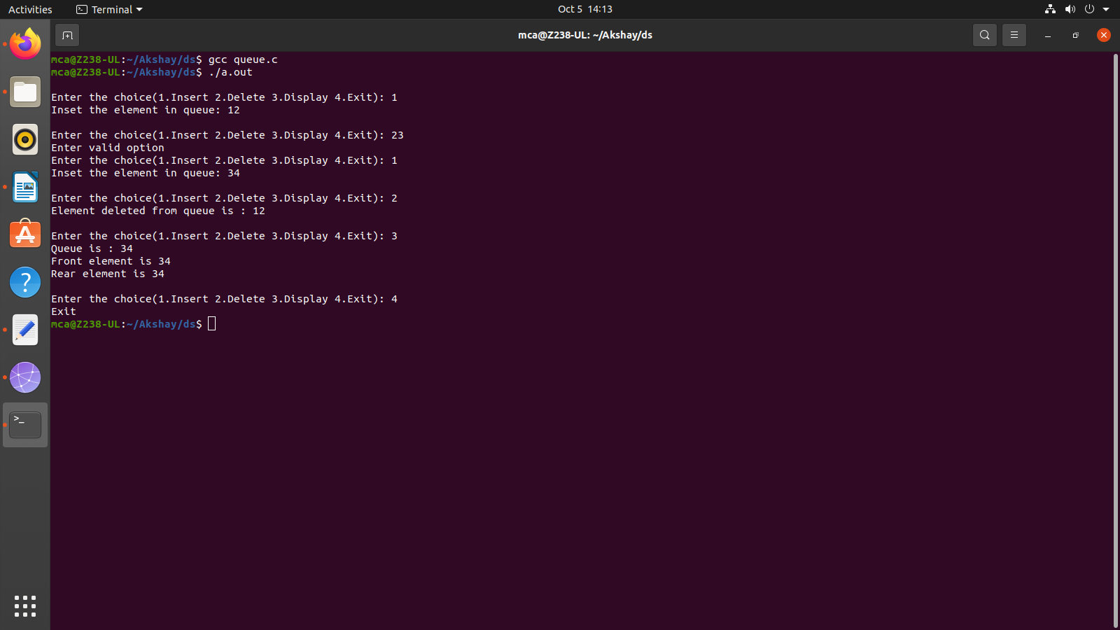

1. **Implement Circular Queue operations (Insert, delete, display front & rear values)**

**Program:**

#include<stdio.h>

#define MAX 10

int q[10],n,choice,front=-1,rear=-1;

void insert(){

int x;

if((front==0 &&rear==MAX-1)||(front==rear+1)){

printf("queue is full");

return;

}else {

printf("Enter the element: ");

scanf("%d", &x);

if (front == -1) {

front = 0;

}

rear=(rear+1)%MAX;

q[rear] = x;

}}

void delete(){

if (front==-1){

printf("Queue is empty ");

}else {

int removed =q[front];

if (front == rear){

front = rear = -1;

}else{

front = (front + 1) % MAX;

}

printf("Element deleted is %d.\n", removed);

}}

void display(){

int i;

printf("\n");

if(rear==-1 && front==-1){

printf("Queue is empty");

}else if (front > rear){

for (i = front;i<n;i++){

printf("%d ", q[i]);

}

for(i=0;i<=rear;i++)

printf("%d ", q[i]);

}else{

for (i = front; i <= rear; i++)

printf("%d ", q[i]);

printf("\nFront element is %d ", q[front]);

printf("\nRear element is %d ", q[rear]);

}}

int main(){

while(choice != 4) {

printf("\nEnter the choice(1.Insert 2.Delete 3.Display 4.Exit): ");

scanf("%d",&choice);

switch(choice) {

case 1:

insert();

break;

case 2:

delete();

break;

case 3:

display();

break;

case 4:

printf("Exit\n");

break;

default:

printf("Enter valid option");

}}

return 0;

}

**Output:**

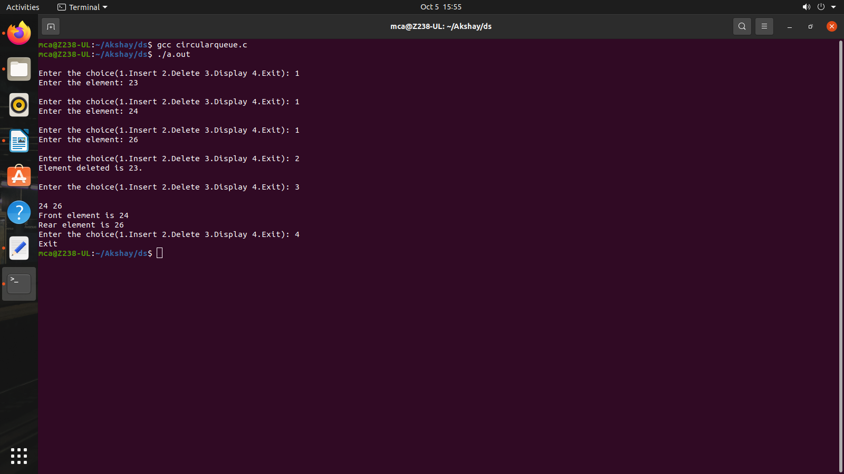

1. **Implement singly linked list (Insert at the head, insert at tail, insert at a position, delete at the head, delete at tail, delete form a position, search an element).**

**Program:**

#include <stdio.h>

#include <stdlib.h>

struct Node {

int data;

struct Node* next;

};

struct Node* createNode(int data) {

struct Node* newNode = (struct Node*)malloc(sizeof(struct Node));

newNode->data = data;

newNode->next = NULL;

return newNode;

}

void insertAtHead(struct Node** head, int data) {

struct Node* newNode = createNode(data);

newNode->next = *head;

*head = newNode;

}

void insertAtTail(struct Node** head, int data) {

struct Node* newNode = createNode(data);

struct Node* current = *head;

if (*head == NULL) {

*head = newNode;

return;

}

while (current->next != NULL) {

current = current->next;

}

current->next = newNode;

}

void insertAtPosition(struct Node** head, int data, int position) {

if (position < 0) {

printf("Invalid position\n");

return;

}

if (position == 0 || *head == NULL) {

insertAtHead(head, data);

return;

}

struct Node* newNode = createNode(data);

struct Node* current = *head;

int currentPosition = 0;

while (currentPosition < position - 1 && current->next != NULL) {

current = current->next;

currentPosition++;

}

newNode->next = current->next;

current->next = newNode;

}

void deleteAtHead(struct Node** head) {

if (*head == NULL) {

printf("List is empty\n");

return;

}

struct Node* temp = *head;

*head = (*head)->next;

free(temp);

}

void deleteAtTail(struct Node** head) {

if (*head == NULL) {

printf("List is empty\n");

return;

}

if ((*head)->next == NULL) {

free(*head);

*head = NULL;

return;

}

struct Node* current = *head;

while (current->next->next != NULL) {

current = current->next;

}

free(current->next);

current->next = NULL;

}

void deleteAtPosition(struct Node** head, int position) {

if (*head == NULL) {

printf("List is empty\n");

return;

}

if (position < 0) {

printf("Invalid position\n");

return;

}

if (position == 0) {

deleteAtHead(head);

return;

}

struct Node* current = *head;

int currentPosition = 0;

while (currentPosition < position - 1 && current->next != NULL) {

current = current->next;

currentPosition++;

}

if (current->next == NULL || current->next->next == NULL) {

printf("Invalid position\n");

return;

}

struct Node* temp = current->next;

current->next = current->next->next;

free(temp);

}

int searchElement(struct Node* head, int key) {

struct Node* current = head;

int position = 0;

while (current != NULL) {

if (current->data == key) {

return position;

}

current = current->next;

position++;

}

return -1;

}

void printList(struct Node* head) {

struct Node* current = head;

while (current != NULL) {

printf("%d -> ", current->data);

current = current->next;

}

printf("NULL\n");

}

void freeList(struct Node* head) {

while (head != NULL) {

struct Node* temp = head;

head = head->next;

free(temp);

}

}

int main() {

struct Node* head = NULL;

int choice, data, position, key;

while (1) {

printf("\nMenu:\n");

printf("1. Insert at head\n");

printf("2. Insert at tail\n");

printf("3. Insert at a position\n");

printf("4. Delete at head\n");

printf("5. Delete at tail\n");

printf("6. Delete at a position\n");

printf("7. Search for an element\n");

printf("8. Print list\n");

printf("9. Exit\n");

printf("Enter your choice: ");

scanf("%d", &choice);

switch (choice) {

case 1:

printf("Enter data to insert at head: ");

scanf("%d", &data);

insertAtHead(&head, data);

break;

case 2:

printf("Enter data to insert at tail: ");

scanf("%d", &data);

insertAtTail(&head, data);

break;

case 3:

printf("Enter data to insert: ");

scanf("%d", &data);

printf("Enter position to insert at: ");

scanf("%d", &position);

insertAtPosition(&head, data, position);

break;

case 4:

deleteAtHead(&head);

break;

case 5:

deleteAtTail(&head);

break;

case 6:

printf("Enter position to delete from: ");

scanf("%d", &position);

deleteAtPosition(&head, position);

break;

case 7:

printf("Enter element to search for: ");

scanf("%d", &key);

position = searchElement(head, key);

if (position != -1) {

printf("%d found at position %d\n", key, position);

} else {

printf("%d not found in the linked list\n", key);

}

break;

case 8:

printf("Linked List: ");

printList(head);

break;

case 9:

freeList(head);

exit(0);

default:

printf("Invalid choice\n");

}

}

return 0;

}

**Output:**

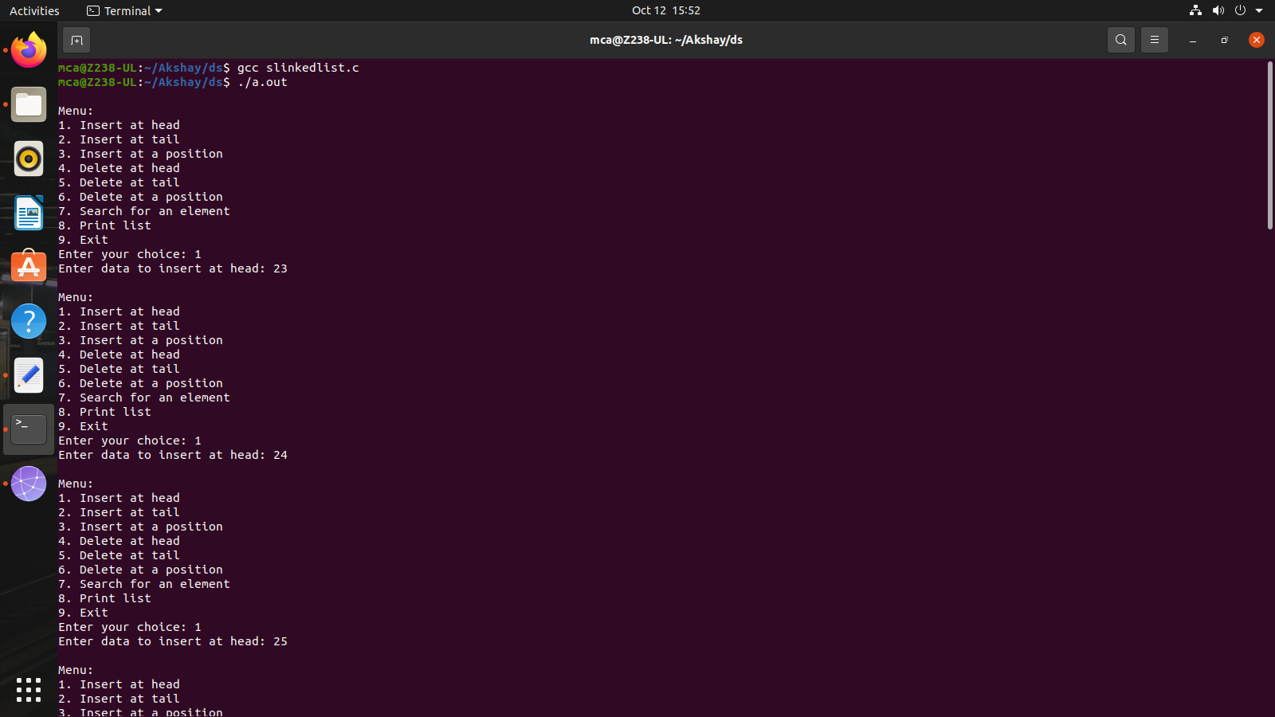

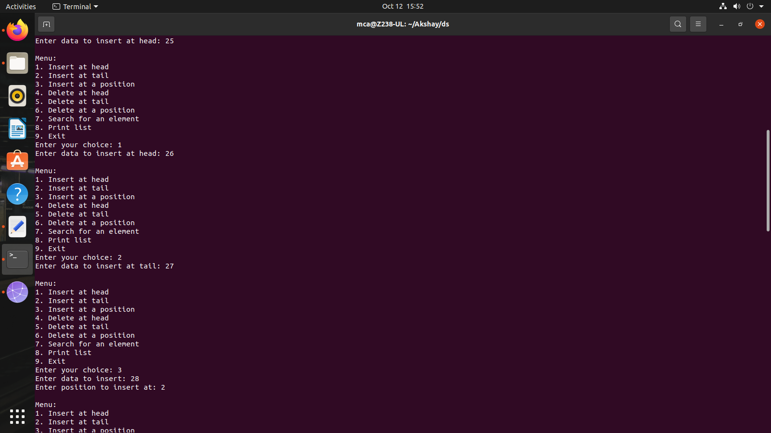

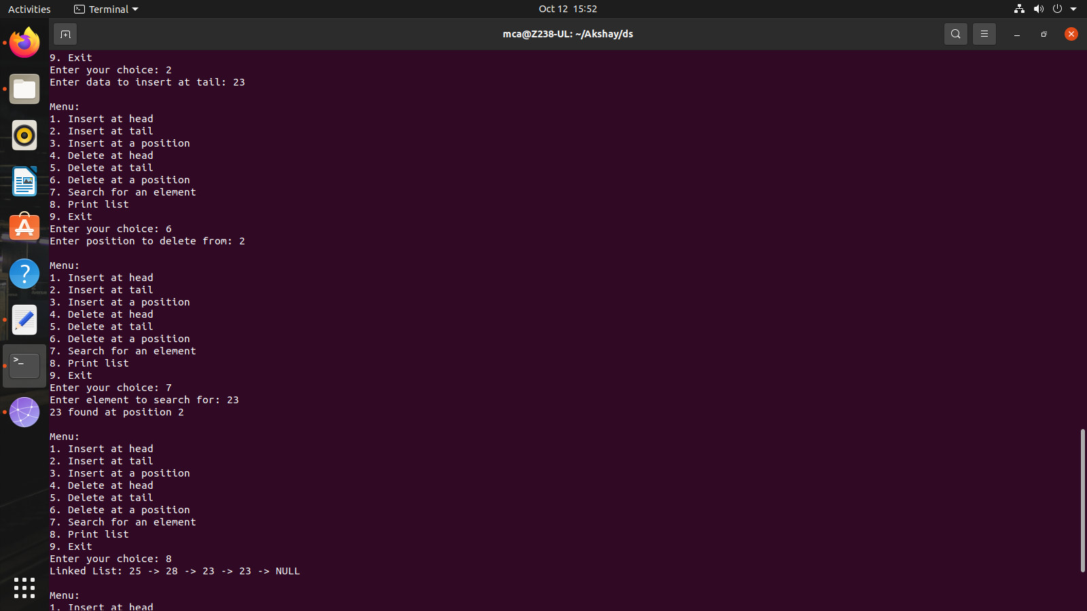

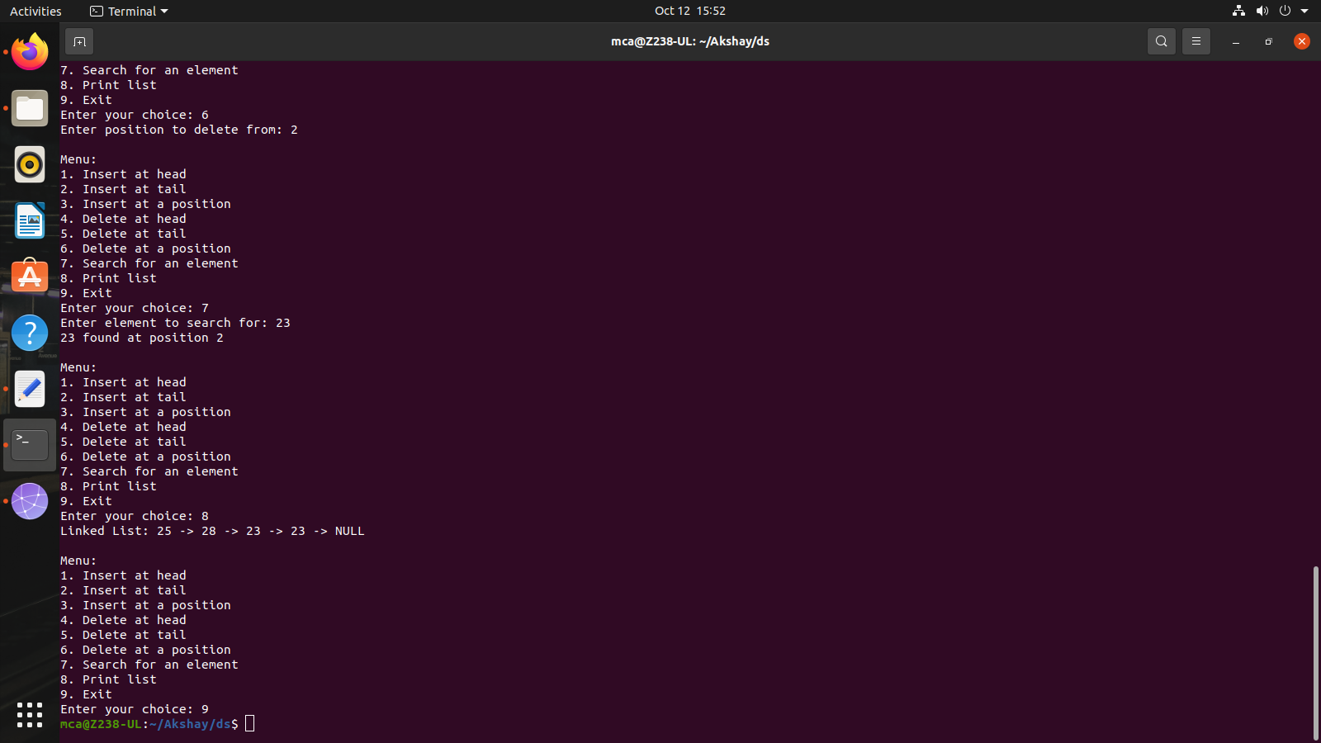

1. **Implement doubly linked list (Insert at the head, insert at tail, insert at a position, delete at the head, delete at tail, delete form a position, search an element).**

**Program:**

#include <stdio.h>

#include <stdlib.h>

struct Node {

int data;

struct Node* prev;

struct Node* next;

};

struct Node* createNode(int data) {

struct Node* newNode = (struct Node*)malloc(sizeof(struct Node));

if (newNode == NULL) {

printf("Memory allocation failed.\n");

exit(1);

}

newNode->data = data;

newNode->prev = NULL;

newNode->next = NULL;

return newNode;

}

void insertAtHead(struct Node** head, int data) {

struct Node* newNode = createNode(data);

if (*head != NULL) {

(*head)->prev = newNode;

}

newNode->next = *head;

*head = newNode;

}

void insertAtTail(struct Node** head, int data) {

struct Node* newNode = createNode(data);

if (*head == NULL) {

*head = newNode;

return;

}

struct Node* current = *head;

while (current->next != NULL) {

current = current->next;

}

current->next = newNode;

newNode->prev = current;

}

void insertAtPosition(struct Node** head, int data, int position) {

if (position < 0) {

printf("Invalid position. Position must be non-negative.\n");

return;

}

if (position == 0) {

insertAtHead(head, data);

return;

}

struct Node* newNode = createNode(data);

struct Node* current = *head;

int currentPosition = 0;

while (current != NULL && currentPosition < position - 1) {

current = current->next;

currentPosition++;

}

if (current == NULL) {

printf("Position exceeds the length of the list.\n");

return;

}

newNode->prev = current;

newNode->next = current->next;

if (current->next != NULL) {

current->next->prev = newNode;

}

current->next = newNode;

}

void deleteAtHead(struct Node** head) {

if (*head == NULL) {

printf("List is empty. Cannot delete.\n");

return;

}

struct Node* temp = *head;

*head = (*head)->next;

if (*head != NULL) {

(*head)->prev = NULL;

}

free(temp);

}

void deleteAtTail(struct Node** head) {

if (*head == NULL) {

printf("List is empty. Cannot delete.\n");

return;

}

if ((*head)->next == NULL) {

free(*head);

*head = NULL;

return;

}

struct Node* current = *head;

while (current->next != NULL) {

current = current->next;

}

current->prev->next = NULL;

free(current);

}

void deleteAtPosition(struct Node** head, int position) {

if (*head == NULL) {

printf("List is empty. Cannot delete.\n");

return;

}

if (position < 0) {

printf("Invalid position. Position must be non-negative.\n");

return;

}

if (position == 0) {

deleteAtHead(head);

return;

}

struct Node* current = *head;

int currentPosition = 0;

while (current != NULL && currentPosition < position) {

current = current->next;

currentPosition++;

}

if (current == NULL) {

printf("Position exceeds the length of the list.\n");

return;

}

current->prev->next = current->next;

if (current->next != NULL) {

current->next->prev = current->prev;

}

free(current);

}

int search(struct Node* head, int key) {

struct Node* current = head;

int position = 0;

while (current != NULL) {

if (current->data == key) {

return position;

}

current = current->next;

position++;

}

return -1;

}

void displayForward(struct Node* head) {

struct Node* current = head;

while (current != NULL) {

printf("%d -> ", current->data);

current = current->next;

}

printf("NULL\n");

}

void displayBackward(struct Node* head) {

struct Node* current = head;

while (current != NULL && current->next != NULL) {

current = current->next;

}

while (current != NULL) {

printf("%d -> ", current->data);

current = current->prev;

}

printf("NULL\n");

}

void freeList(struct Node* head) {

struct Node* current = head;

while (current != NULL) {

struct Node* temp = current;

current = current->next;

free(temp);

}

}

int main() {

struct Node* head = NULL;

int choice, data, position;

while (1) {

printf("\nDoubly Linked List Operations:\n");

printf("1. Insert at the Head\n");

printf("2. Insert at the Tail\n");

printf("3. Insert at a Position\n");

printf("4. Delete at the Head\n");

printf("5. Delete at the Tail\n");

printf("6. Delete at a Position\n");

printf("7. Search for an Element\n");

printf("8. Display Forward\n");

printf("9. Display Backward\n");

printf("10. Exit\n");

printf("Enter your choice: ");

scanf("%d", &choice);

switch (choice) {

case 1:

printf("Enter data to insert at the head: ");

scanf("%d", &data);

insertAtHead(&head, data);

break;

case 2:

printf("Enter data to insert at the tail: ");

scanf("%d", &data);

insertAtTail(&head, data);

break;

case 3:

printf("Enter data to insert: ");

scanf("%d", &data);

printf("Enter position to insert at: ");

scanf("%d", &position);

insertAtPosition(&head, data, position);

break;

case 4:

deleteAtHead(&head);

break;

case 5:

deleteAtTail(&head);

break;

case 6:

printf("Enter position to delete: ");

scanf("%d", &position);

deleteAtPosition(&head, position);

break;

case 7:

printf("Enter element to search: ");

scanf("%d", &data);

position = search(head, data);

if (position != -1) {

printf("Element %d found at position .%d\n", data, position);

} else {

printf("Element %d not found in the linked list.\n", data);

}

break;

case 8:

printf("Doubly Linked List (Forward): ");

displayForward(head);

break;

case 9:

printf("Doubly Linked List (Backward): ");

displayBackward(head);

break;

case 10:

freeList(head);

exit(0);

break;

default:

printf("Invalid choice. Please enter a valid option.\n");

}

}

return 0;

}

**Output:**

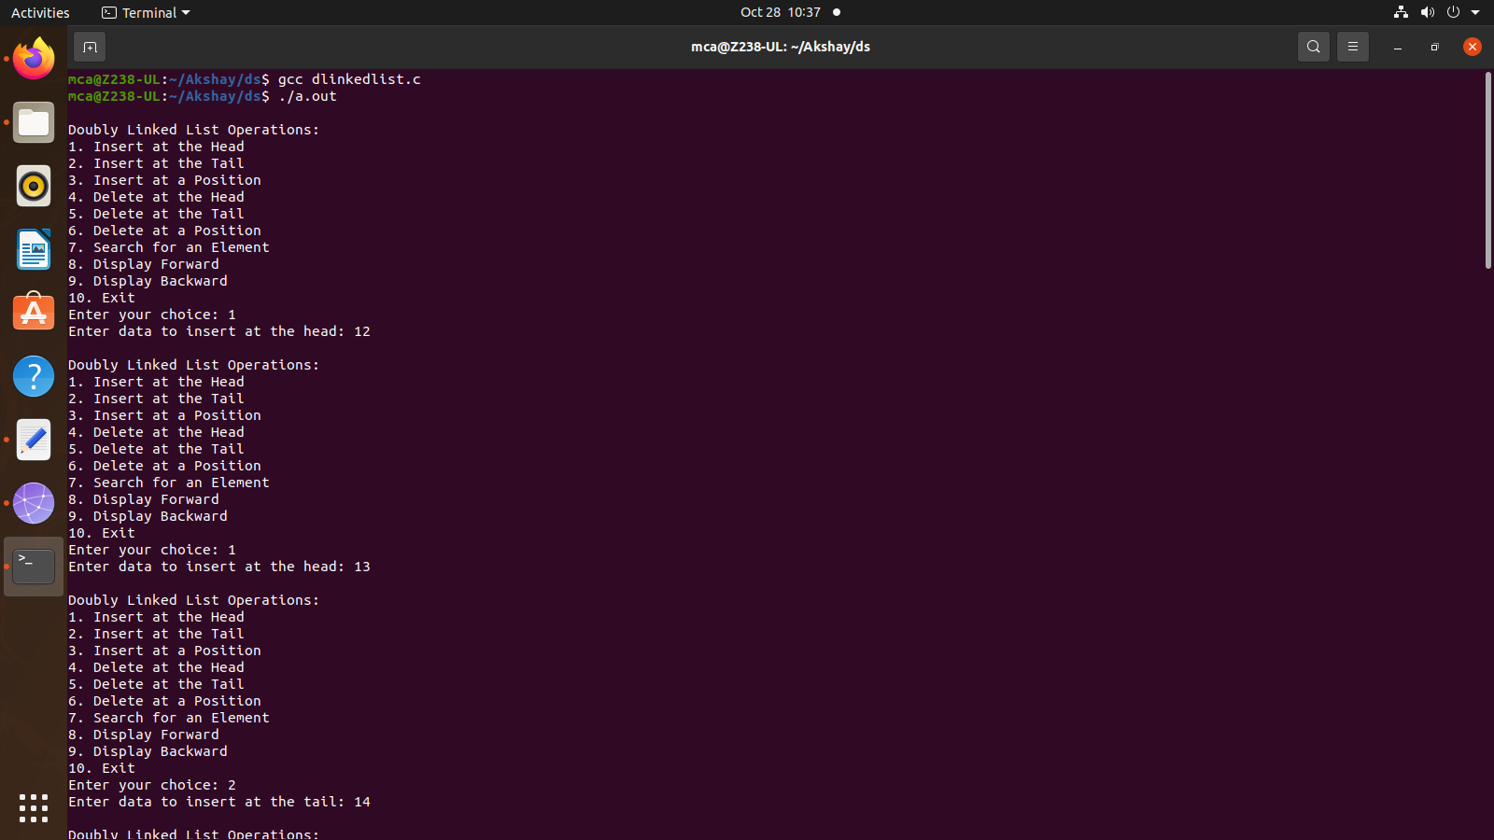

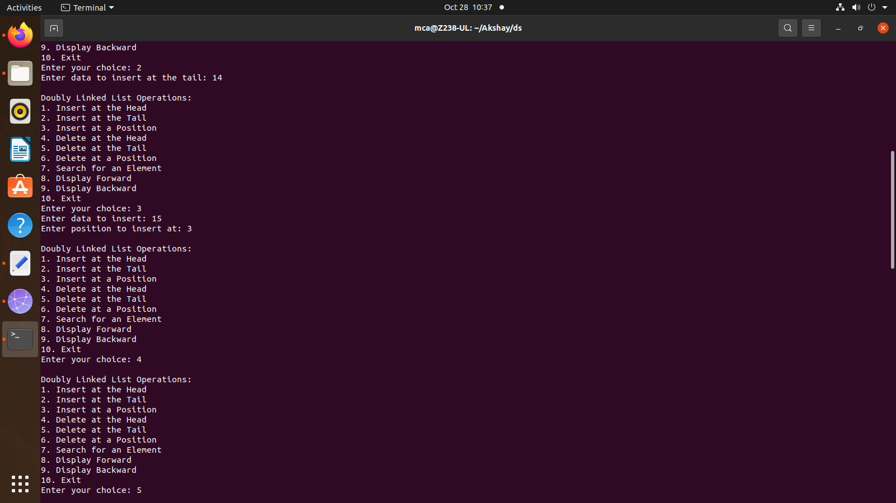

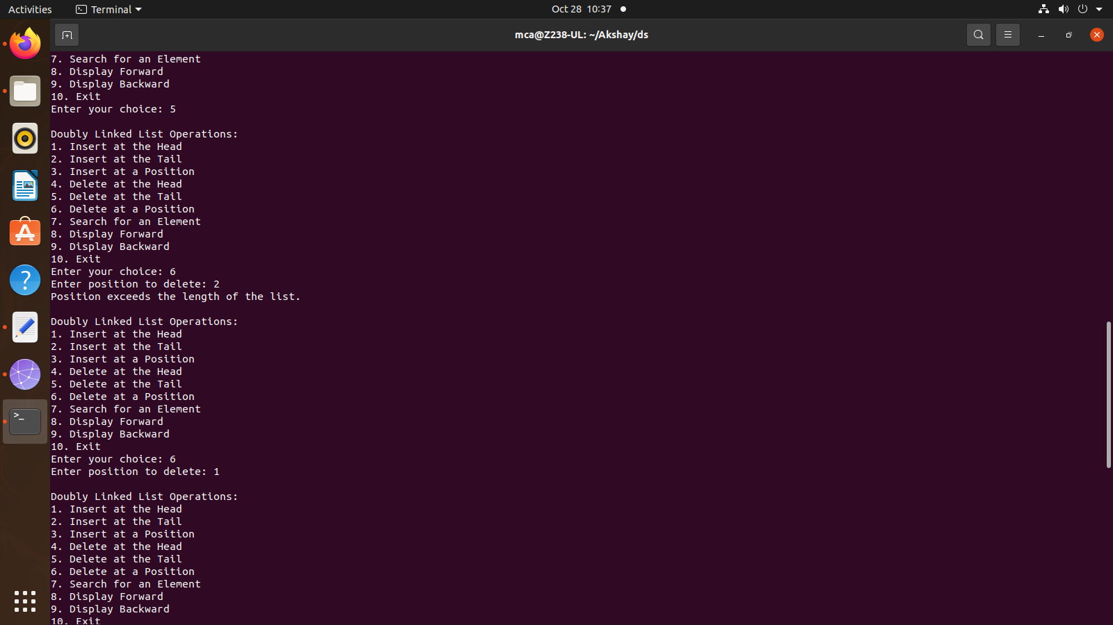

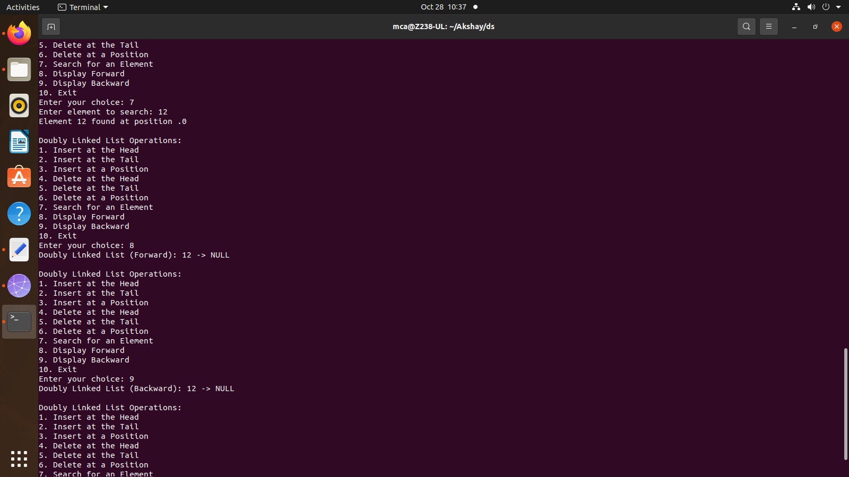

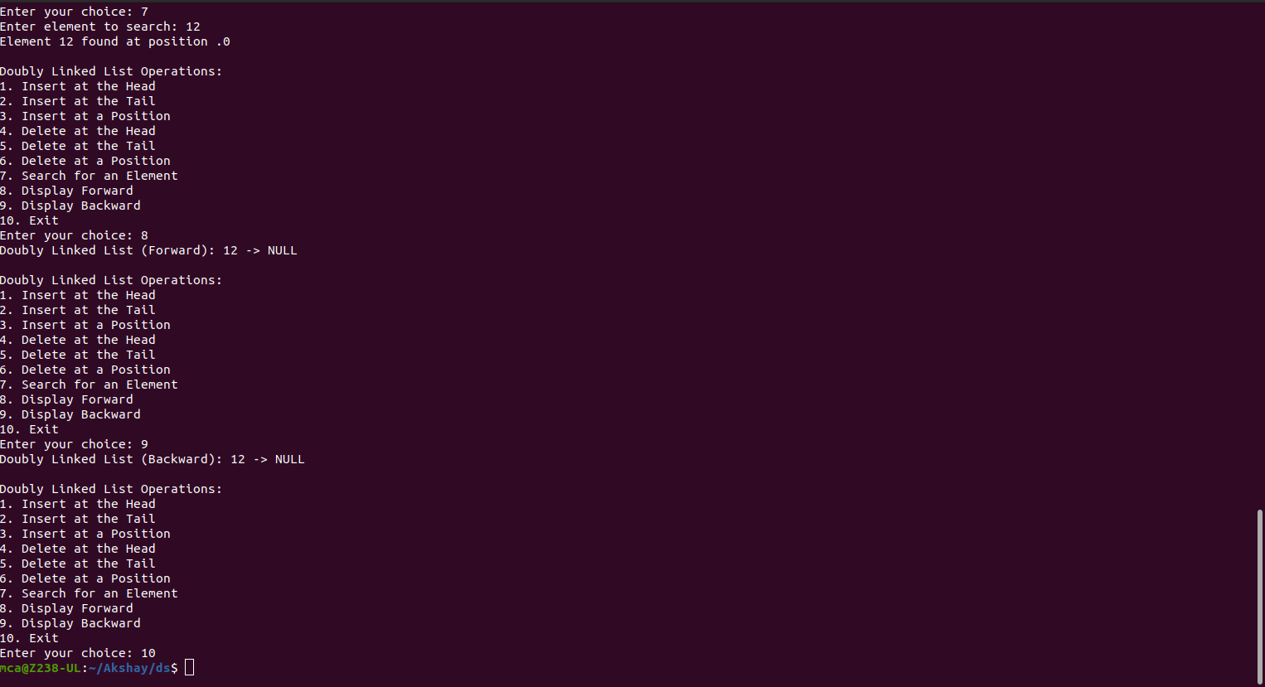

1. **Implement circular linked list (Insert at the head, insert at tail, insert at a position, delete at the head, delete at tail, delete form a position, search an element).**

**Program:**

#include <stdio.h>

#include <stdlib.h>

struct Node {

int data;

struct Node* next;

};

struct Node* head = NULL;

void insertAtHead(int value) {

struct Node* newNode = (struct Node*)malloc(sizeof(struct Node));

newNode->data = value;

if (head == NULL) {

newNode->next = newNode;

head = newNode;

return;

}

struct Node* temp = head;

while (temp->next != head)

temp = temp->next;

temp->next = newNode;

newNode->next = head;

head = newNode;

}

void insertAtTail(int value) {

struct Node* newNode = (struct Node*)malloc(sizeof(struct Node));

newNode->data = value;

if (head == NULL) {

newNode->next = newNode;

head = newNode;

return;

}

struct Node* temp = head;

while (temp->next != head)

temp = temp->next;

temp->next = newNode;

newNode->next = head;

}

void insertAtPosition(int value, int position) {

if (position == 1) {

insertAtHead(value);

return;

}

struct Node* newNode = (struct Node*)malloc(sizeof(struct Node));

newNode->data = value;

struct Node* temp = head;

for (int i = 1; i < position - 1 && temp->next != head; i++)

temp = temp->next;

newNode->next = temp->next;

temp->next = newNode;

}

void deleteAtHead() {

if (head == NULL) {

printf("List is empty. Cannot delete.\n");

return;

}

if (head->next == head) {

free(head);

head = NULL;

return;

}

struct Node* temp = head;

while (temp->next != head)

temp = temp->next;

temp->next = head->next;

struct Node* toDelete = head;

head = head->next;

free(toDelete);

}

void deleteAtTail() {

if (head == NULL) {

printf("List is empty. Cannot delete.\n");

return;

}

if (head->next == head) {

free(head);

head = NULL;

return;

}

struct Node* temp = head;

while (temp->next->next != head)

temp = temp->next;

struct Node* toDelete = temp->next;

temp->next = head;

free(toDelete);

}

void deleteAtPosition(int position) {

if (head == NULL) {

printf("List is empty. Cannot delete.\n");

return;

}

if (position == 1) {

deleteAtHead();

return;

}

struct Node* temp = head;

for (int i = 1; i < position - 1 && temp->next != head; i++)

temp = temp->next;

if (temp->next == head) {

printf("Invalid position.\n");

return;

}

struct Node* toDelete = temp->next;

temp->next = temp->next->next;

free(toDelete);

}

void search(int value) {

struct Node* temp = head;

int position = 1;

do {

if (temp->data == value) {

printf("%d found at position %d.\n", value, position);

return;

}

temp = temp->next;

position++;

} while (temp != head);

printf("%d not found in the list.\n", value);

}

void display() {

if (head == NULL) {

printf("List is empty.\n");

return;

}

struct Node* temp = head;

do {

printf("%d ", temp->data);

temp = temp->next;

} while (temp != head);

printf("\n");

}

int main() {

int choice, value, position;

do {

printf("\nCircular Linked List Operations:\n");

printf("1. Insert at Head\n2. Insert at Tail\n3. Insert at Position\n4. Delete at Head\n5. Delete at Tail\n6. Delete at Position\n7. Search\n8. Display\n9. Quit\n");

printf("Enter your choice: ");

scanf("%d", &choice);

switch (choice) {

case 1:

printf("Enter value to insert: ");

scanf("%d", &value);

insertAtHead(value);

break;

case 2:

printf("Enter value to insert: ");

scanf("%d", &value);

insertAtTail(value);

break;

case 3:

printf("Enter value to insert: ");

scanf("%d", &value);

printf("Enter position: ");

scanf("%d", &position);

insertAtPosition(value, position);

break;

case 4:

deleteAtHead();

break;

case 5:

deleteAtTail();

break;

case 6:

printf("Enter position: ");

scanf("%d", &position);

deleteAtPosition(position);

break;

case 7:

printf("Enter value to search: ");

scanf("%d", &value);

search(value);

break;

case 8:

display();

break;

case 9:

printf("Exiting...\n");

break;

default:

printf("Invalid choice. Please try again.\n");

break;

}

} while (choice != 9);

return 0;

}

**Output:**

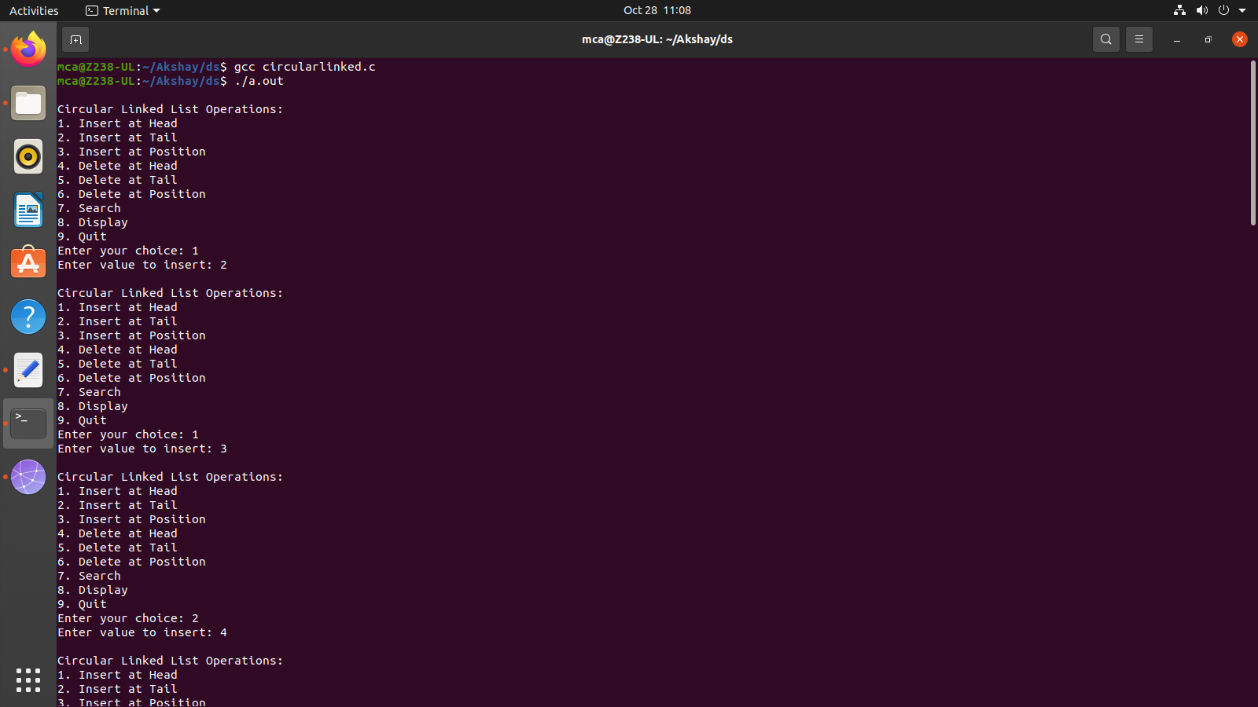

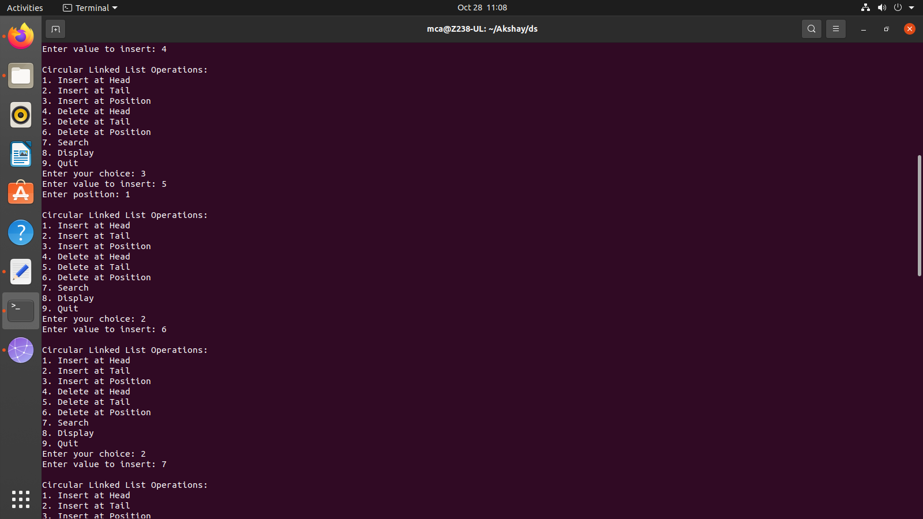

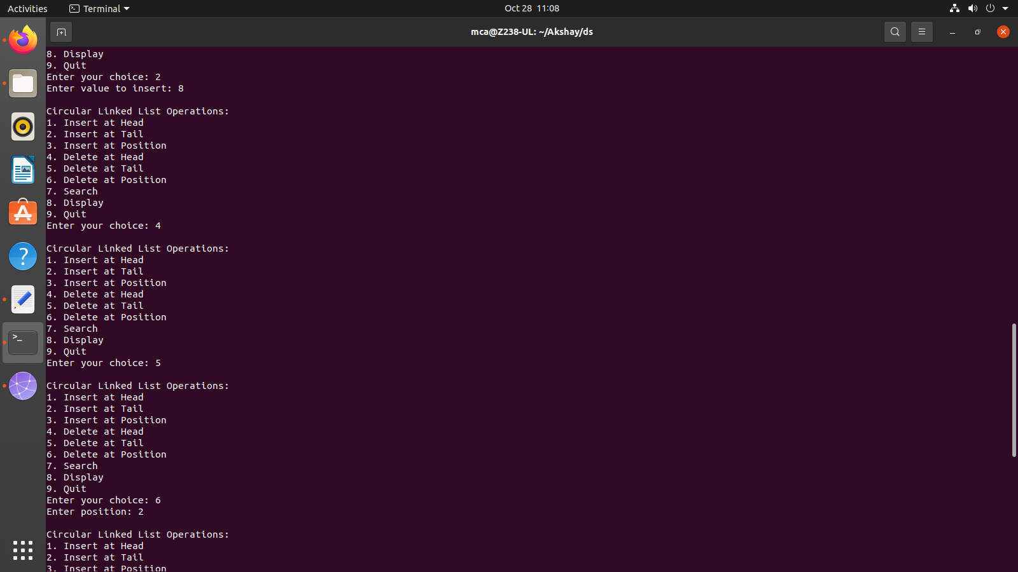

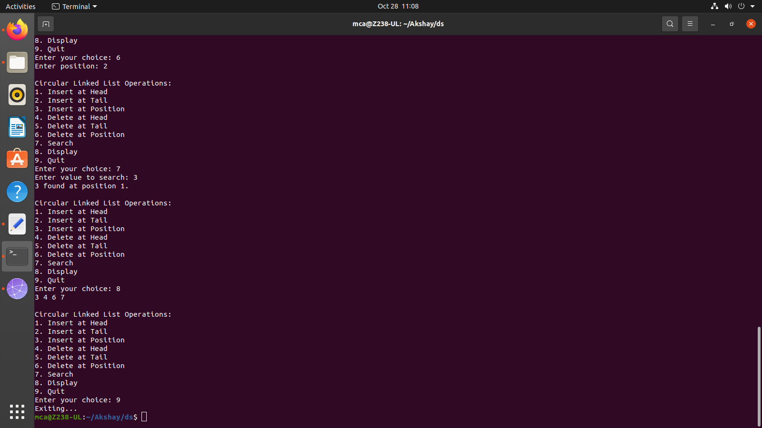

1. **Implement binary search tree**

**Program:**

#include <stdio.h>

#include <stdlib.h>

struct Node {

int data;

struct Node* left;

struct Node* right;

};

struct Node* createNode(int value) {

struct Node* newNode = (struct Node*)malloc(sizeof(struct Node));

newNode->data = value;

newNode->left = newNode->right = NULL;

return newNode;

}

struct Node* insert(struct Node* root, int value) {

if (root == NULL)

return createNode(value);

if (value < root->data)

root->left = insert(root->left, value);

else if (value > root->data)

root->right = insert(root->right, value);

return root;

}

struct Node* findMin(struct Node* node) {

struct Node* current = node;

while (current && current->left != NULL)

current = current->left;

return current;

}

struct Node* deleteNode(struct Node* root, int value) {

if (root == NULL)

return root;

if (value < root->data)

root->left = deleteNode(root->left, value);

else if (value > root->data)

root->right = deleteNode(root->right, value);

else {

if (root->left == NULL) {

struct Node* temp = root->right;

free(root);

return temp;

} else if (root->right == NULL) {

struct Node* temp = root->left;

free(root);

return temp;

}

struct Node* temp = findMin(root->right);

root->data = temp->data;

root->right = deleteNode(root->right, temp->data);

}

return root;

}

struct Node* search(struct Node* root, int value) {

if (root == NULL || root->data == value)

return root;

if (value < root->data)

return search(root->left, value);

return search(root->right, value);

}

void inOrderTraversal(struct Node* root) {

if (root != NULL) {

inOrderTraversal(root->left);

printf("%d ", root->data);

inOrderTraversal(root->right);

}

}

int main() {

struct Node* root = NULL;

int choice, value;

do {

printf("\nBinary Search Tree Operations:\n");

printf("1. Insert\n2. Delete\n3. Search\n4. In-order Traversal\n5. Quit\n");

printf("Enter your choice: ");

scanf("%d", &choice);

switch (choice) {

case 1:

printf("Enter value to insert: ");

scanf("%d", &value);

root = insert(root, value);

break;

case 2:

printf("Enter value to delete: ");

scanf("%d", &value);

root = deleteNode(root, value);

break;

case 3:

printf("Enter value to search: ");

scanf("%d", &value);

struct Node* result = search(root, value);

if (result != NULL)

printf("%d found in the tree.\n", value);

else

printf("%d not found in the tree.\n", value);

break;

case 4:

printf("In-order Traversal: ");

inOrderTraversal(root);

printf("\n");

break;

case 5:

printf("Exiting...\n");

break;

default:

printf("Invalid choice. Please try again.\n");

break;

}

} while (choice != 5);

return 0;

}

**Output:**

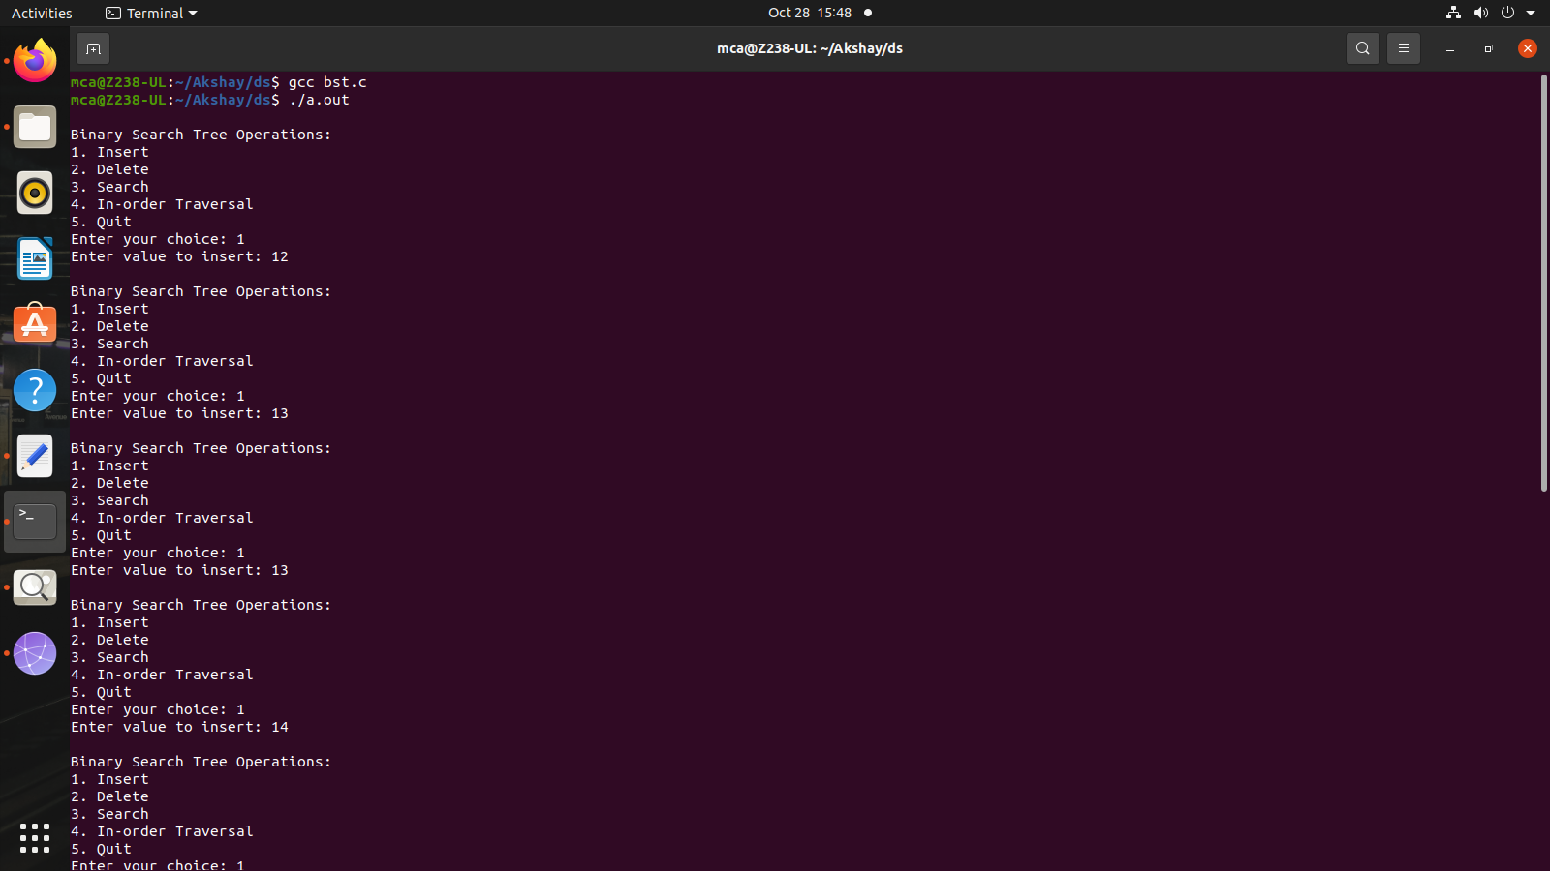

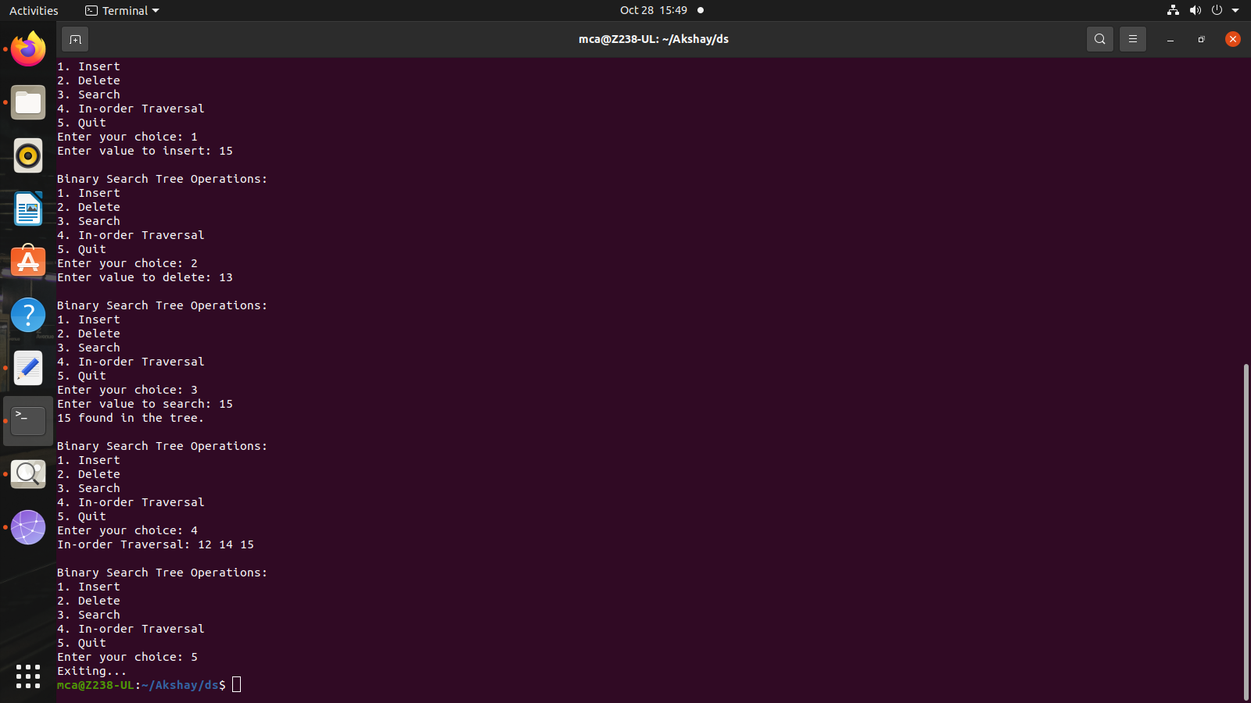

1. **Implement balanced-binary-search tree**

**Program:**

#include <stdio.h>

#include <stdlib.h>

#define MAX_SIZE 100

struct Node {

int data;

int height;

struct Node* left;

struct Node* right;

};

struct Node* createNode(int value) {

struct Node* newNode = (struct Node*)malloc(sizeof(struct Node));

newNode->data = value;

newNode->height = 1;

newNode->left = newNode->right = NULL;

return newNode;

}

int calculateHeight(struct Node* node) {

int leftHeight = (node->left) ? node->left->height : 0;

int rightHeight = (node->right) ? node->right->height : 0;

return (leftHeight > rightHeight) ? leftHeight + 1 : rightHeight + 1;

}

void updateHeight(struct Node* node) {

node->height = calculateHeight(node);

}

struct Node* rightRotate(struct Node* y) {

struct Node* x = y->left;

struct Node* T = x->right;

x->right = y;

y->left = T;

updateHeight(y);

updateHeight(x);

return x;

}

struct Node* leftRotate(struct Node* x) {

struct Node* y = x->right;

struct Node* T = y->left;

y->left = x;

x->right = T;

updateHeight(x);

updateHeight(y);

return y;

}

struct Node* balanceNode(struct Node* node) {

int balance = (node->left ? node->left->height : 0) - (node->right ? node->right->height : 0);

if (balance > 1) {

if (node->left->left) {

return rightRotate(node);

} else {

node->left = leftRotate(node->left);

return rightRotate(node);

}

}

if (balance < -1) {

if (node->right->right) {

return leftRotate(node);

} else {

node->right = rightRotate(node->right);

return leftRotate(node);

}

}

return node;

}

struct Node* insert(struct Node* root, int value) {

if (root == NULL) {

struct Node* newNode = createNode(value);

return newNode;

}

if (value < root->data)

root->left = insert(root->left, value);

else if (value > root->data)

root->right = insert(root->right, value);

updateHeight(root);

return balanceNode(root);

}

struct Node* findMin(struct Node* node) {

struct Node* current = node;

while (current && current->left != NULL)

current = current->left;

return current;

}

struct Node* deleteNode(struct Node* root, int value) {

if (root == NULL)

return root;

if (value < root->data)

root->left = deleteNode(root->left, value);

else if (value > root->data)

root->right = deleteNode(root->right, value);

else {

if (root->left == NULL) {

struct Node* temp = root->right;

free(root);

return temp;

} else if (root->right == NULL) {

struct Node* temp = root->left;

free(root);

return temp;

}

struct Node* temp = findMin(root->right);

root->data = temp->data;

root->right = deleteNode(root->right, temp->data);

}

updateHeight(root);

return balanceNode(root);

}

struct Node* search(struct Node* root, int value) {

if (root == NULL || root->data == value)

return root;

if (value < root->data)

return search(root->left, value);

return search(root->right, value);

}

void inOrderTraversal(struct Node* root) {

if (root != NULL) {

inOrderTraversal(root->left);

printf("%d ", root->data);

inOrderTraversal(root->right);

}

}

int main() {

struct Node* root = NULL;

int choice, value;

do {

printf("\nBalanced Binary Search Tree Operations:\n1. Insert\n2. Delete\n3. Search\n4. In-order Traversal\n 5. Quit\n");

printf("Enter your choice: ");

scanf("%d", &choice);

switch (choice) {

case 1:

printf("Enter value to insert: ");

scanf("%d", &value);

if (search(root, value) == NULL)

root = insert(root, value);

else

printf("%d is already in the tree.\n", value);

break;

case 2:

printf("Enter value to delete: ");

scanf("%d", &value);

if (search(root, value) != NULL)

root = deleteNode(root, value);

else

printf("%d not found in the tree.\n", value);

break;

case 3:

printf("Enter value to search: ");

scanf("%d", &value);

struct Node* result = search(root, value);

if (result != NULL)

printf("%d found in the tree.\n", value);

else

printf("%d not found in the tree.\n", value);

break;

case 4:

printf("In-order Traversal: ");

inOrderTraversal(root);

printf("\n");

break;

case 5:

printf("Exiting...\n");

break;

default:

printf("Invalid choice. Please try again.\n");

break;

}

} while (choice != 5);

while (root != NULL) {

struct Node* temp = root;

root = deleteNode(root, temp->data);

}

return 0;

}

**Output:**

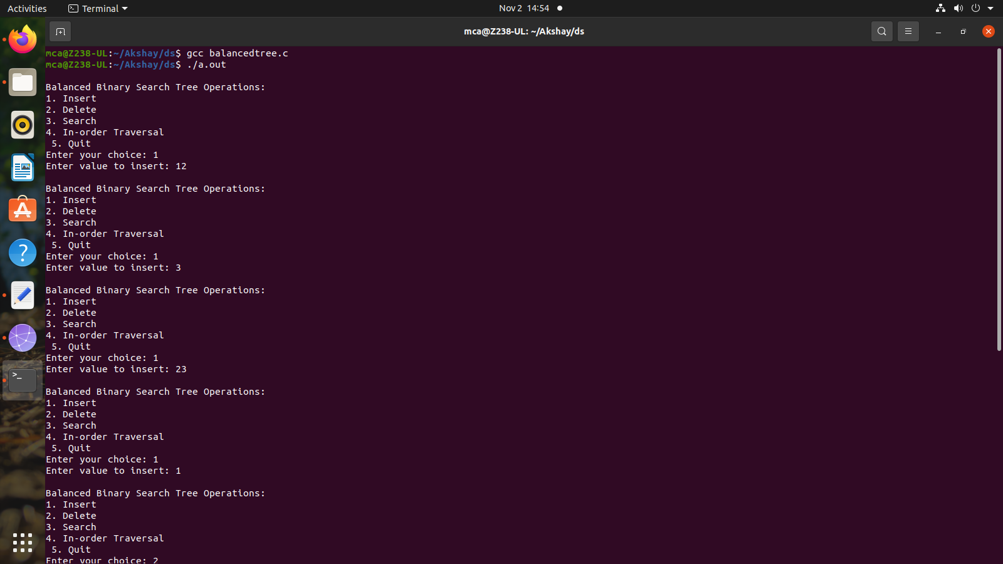

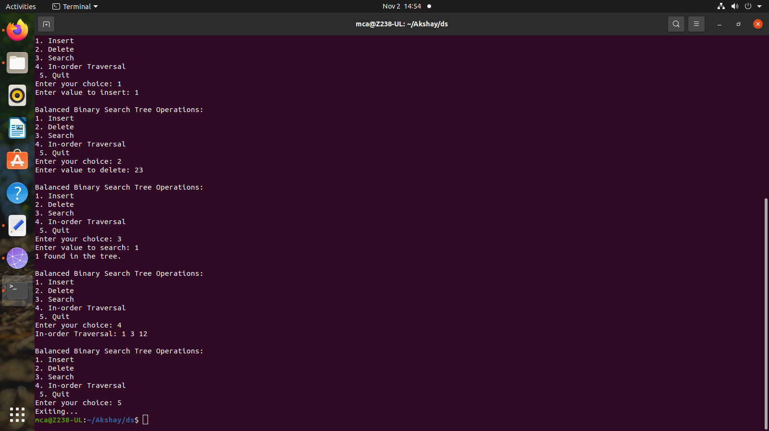

1. **Implement set operations (union, intersection, difference)**

**Program:**

#include <stdio.h>

#define MAX_SIZE 100

int readSet(int set[]) {

int size, i;

printf("Enter the size of the set: ");

scanf("%d", &size);

printf("Enter elements of the set:\n");

for (i = 0; i < size; i++) {

scanf("%d", &set[i]);

}

return size;

}

void displaySet(int set[], int size) {

int i;

printf("Set: { ");

for (i = 0; i < size; i++) {

printf("%d ", set[i]);

}

printf("}\n");

}

int setUnion(int set1[], int size1, int set2[], int size2, int result[]) {

int i, j, k = 0;

for (i = 0; i < size1; i++) {

result[k++] = set1[i];

}

for (i = 0; i < size2; i++) {

int found = 0;

for (j = 0; j < size1; j++) {

if (set2[i] == set1[j]) {

found = 1;

break;

}

}

if (!found) {

result[k++] = set2[i];

}

}

return k;

}

int setIntersection(int set1[], int size1, int set2[], int size2, int result[]) {

int i, j, k = 0;

for (i = 0; i < size1; i++) {

for (j = 0; j < size2; j++) {

if (set1[i] == set2[j]) {

result[k++] = set1[i];

break;

}

}

}

return k;

}

int setDifference(int set1[], int size1, int set2[], int size2, int result[]) {

int i, j, k = 0;

for (i = 0; i < size1; i++) {

int found = 0;

for (j = 0; j < size2; j++) {

if (set1[i] == set2[j]) {

found = 1;

break;

}

}

if (!found) {

result[k++] = set1[i];

}

}

return k;

}

int main() {

int set1[MAX_SIZE], set2[MAX_SIZE], result[MAX_SIZE];

int size1, size2, resultSize;

int choice;

size1 = readSet(set1);

size2 = readSet(set2);

do {

printf("\nSet Operations:\n");

printf("1. Union\n");

printf("2. Intersection\n");

printf("3. Difference (set1 - set2)\n");

printf("4. Display Sets\n");

printf("5. Quit\n");

printf("Enter your choice: ");

scanf("%d", &choice);

switch (choice) {

case 1:

resultSize = setUnion(set1, size1, set2, size2, result);

displaySet(result, resultSize);

break;

case 2:

resultSize = setIntersection(set1, size1, set2, size2, result);

displaySet(result, resultSize);

break;

case 3:

resultSize = setDifference(set1, size1, set2, size2, result);

displaySet(result, resultSize);

break;

case 4:

printf("\nSets:\n");

printf("Set 1: ");

displaySet(set1, size1);

printf("Set 2: ");

displaySet(set2, size2);

break;

case 5:

printf("Exiting...\n");

break;

default:

printf("Invalid choice. Please try again.\n");

break;

}

} while (choice != 5);

return 0;

}

**Output:**

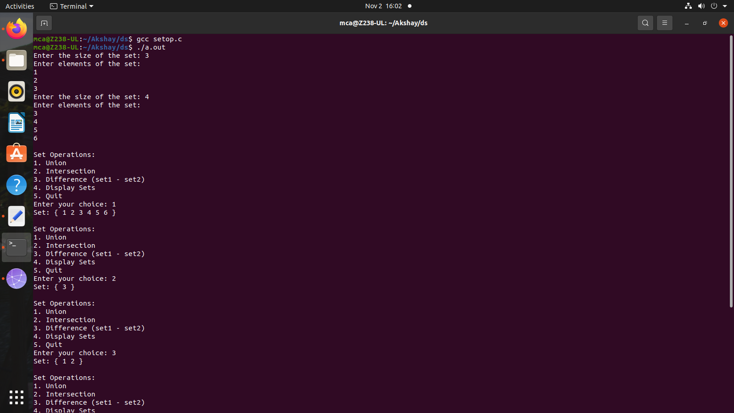

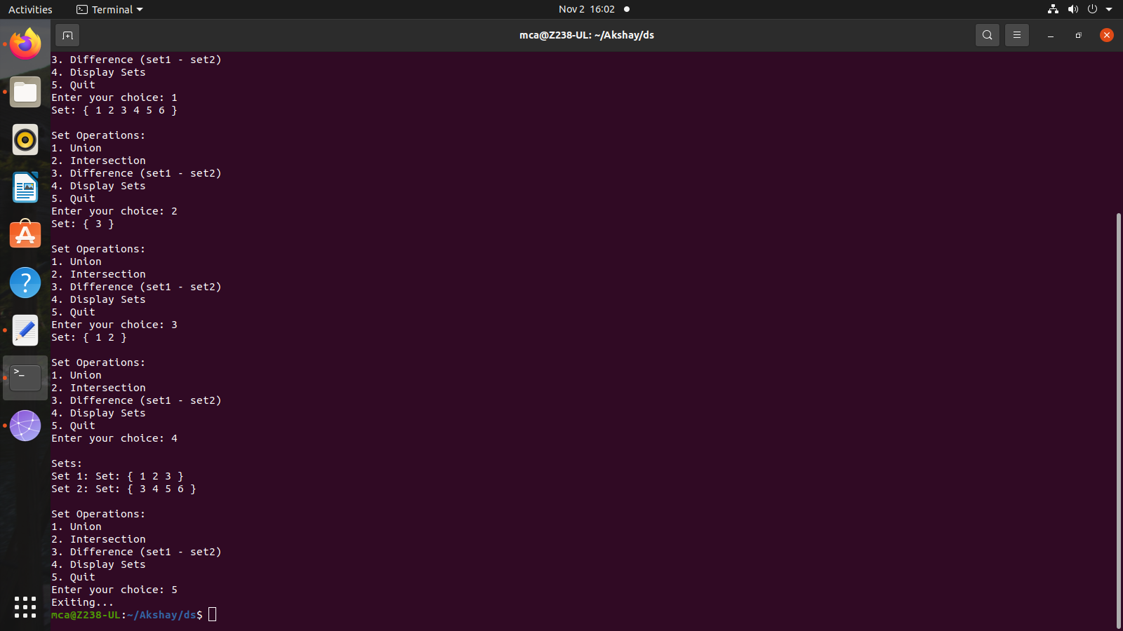

1. **Implement disjoint set operations.**

**Program:**

#include <stdio.h>

#define MAX 100

int parent[MAX], rank[MAX], n;

int find(int x) {

if (x != parent[x])

parent[x] = find(parent[x]);

return parent[x];

}

int main() {

printf("Enter the number of elements: ");

if (scanf("%d", &n) != 1 || n <= 0 || n > MAX) {

printf("Invalid input. Please enter a positive integer less than or equal to %d.\n", MAX);

return 1;

}

for (int i = 0; i < n; i++) {

parent[i] = i;

rank[i] = 0;

}

int choice, x, y;

while (1) {

printf("\nOperations:\n1. Union\n2. Find\n3. Display Set Representatives\n4. Exit\nEnter your choice: ");

if (scanf("%d", &choice) != 1) {

printf("Invalid input. Please enter an integer.\n");

continue;

}

switch (choice) {

case 1:

printf("Enter elements to perform union: ");

if (scanf("%d %d", &x, &y) != 2 || x < 0 || x >= n || y < 0 || y >= n) {

printf("Invalid input. Please enter valid elements.\n");

} else {

int rootX = find(x);

int rootY = find(y);

if (rootX == rootY) {

printf("%d and %d are already in the same set.\n", x, y);

} else {

if (rank[rootX] > rank[rootY]) {

parent[rootY] = rootX;

} else if (rank[rootX] < rank[rootY]) {

parent[rootX] = rootY;

} else {

parent[rootY] = rootX;

rank[rootX]++;

}

printf("Union of %d and %d is performed.\n", x, y);

}

}

break;

case 2:

printf("Enter element to find its set: ");

if (scanf("%d", &x) != 1 || x < 0 || x >= n) {

printf("Invalid input. Please enter a valid element.\n");

} else {

printf("Set representative of %d is %d\n", x, find(x));

}

break;

case 3:

printf("Set Representatives:\n");

for (int i = 0; i < n; i++) {

printf("Element %d belongs to set with representative %d\n", i, find(i));

}

break;

case 4:

return 0;

default:

printf("Invalid choice. Please enter a valid option.\n");

break;

}

}

}

**Output:**

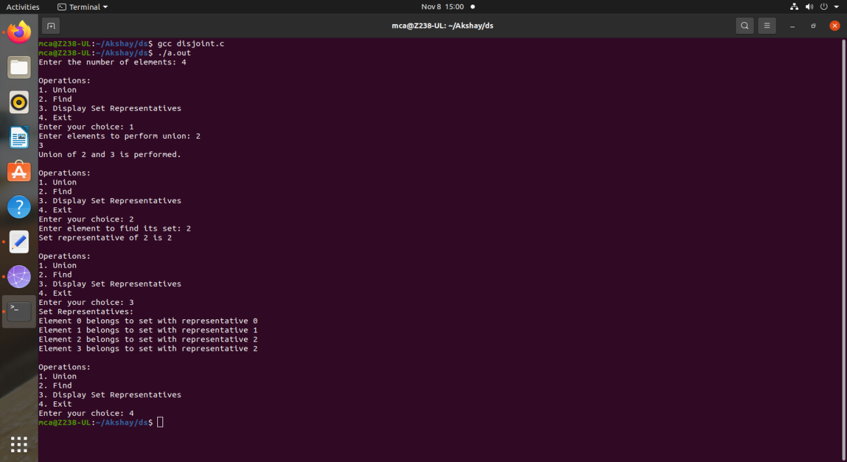

1. **Implement tree traversal methods DFS ( In-order, Pre-Order, Post-Order), and BFS**

**Program:**

#include <stdio.h>

#include <stdlib.h>

struct Node {

int data;

struct Node* left;

struct Node* right;

};

struct Node* createNode(int value) {

struct Node* newNode = (struct Node*)malloc(sizeof(struct Node));

newNode->data = value;

newNode->left = newNode->right = NULL;

return newNode;

}

struct Node* insert(struct Node* root, int value) {

if (root == NULL)

return createNode(value);

if (value < root->data)

root->left = insert(root->left, value);

else if (value > root->data)

root->right = insert(root->right, value);

return root;

}

void inOrderTraversal(struct Node* root) {

if (root != NULL) {

inOrderTraversal(root->left);

printf("%d ", root->data);

inOrderTraversal(root->right);

}

}

void preOrderTraversal(struct Node* root) {

if (root != NULL) {

printf("%d ", root->data);

preOrderTraversal(root->left);

preOrderTraversal(root->right);

}

}

void postOrderTraversal(struct Node* root) {

if (root != NULL) {

postOrderTraversal(root->left);

postOrderTraversal(root->right);

printf("%d ", root->data);

}

}

void breadthFirstSearch(struct Node* root) {

if (root == NULL)

return;

struct Node* queue[100];

int front = -1, rear = -1;

queue[++rear] = root;

while (front < rear) {

struct Node* current = queue[++front];

printf("%d ", current->data);

if (current->left != NULL)

queue[++rear] = current->left;

if (current->right != NULL)

queue[++rear] = current->right;

}

}

int main() {

struct Node* root = NULL;

int choice, value;

do {

printf("\nBinary Tree Operations:\n1. Insert\n2. In-order Traversal\n3. Pre-order Traversal\n4. Post-order Traversal\n5. Breadth-First Search (BFS)\n6. Quit\n");

printf("Enter your choice: ");

scanf("%d", &choice);

switch (choice) {

case 1:

printf("Enter value to insert: ");

scanf("%d", &value);

root = insert(root, value);

break;

case 2:

printf("In-order Traversal: ");

inOrderTraversal(root);

printf("\n");

break;

case 3:

printf("Pre-order Traversal: ");

preOrderTraversal(root);

printf("\n");

break;

case 4:

printf("Post-order Traversal: ");

postOrderTraversal(root);

printf("\n");

break;

case 5:

printf("Breadth-First Search (BFS): ");

breadthFirstSearch(root);

printf("\n");

break;

case 6:

printf("Exiting...\n");

break;

default:

printf("Invalid choice. Please try again.\n");

break;

}

} while (choice != 6);

return 0;

}

**Output:**

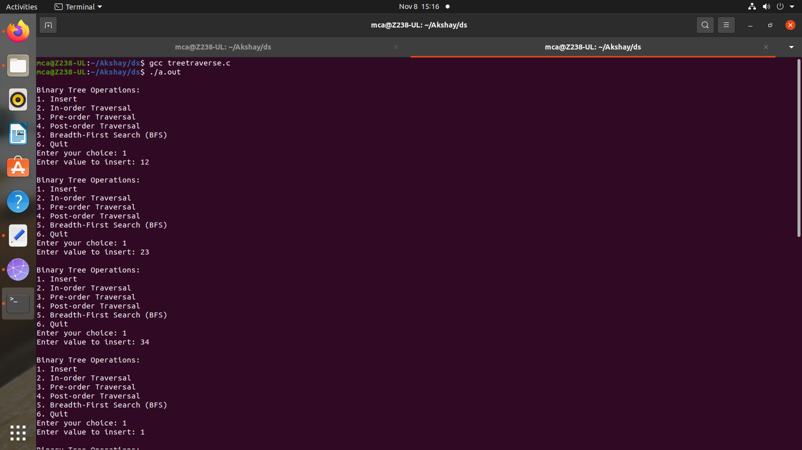

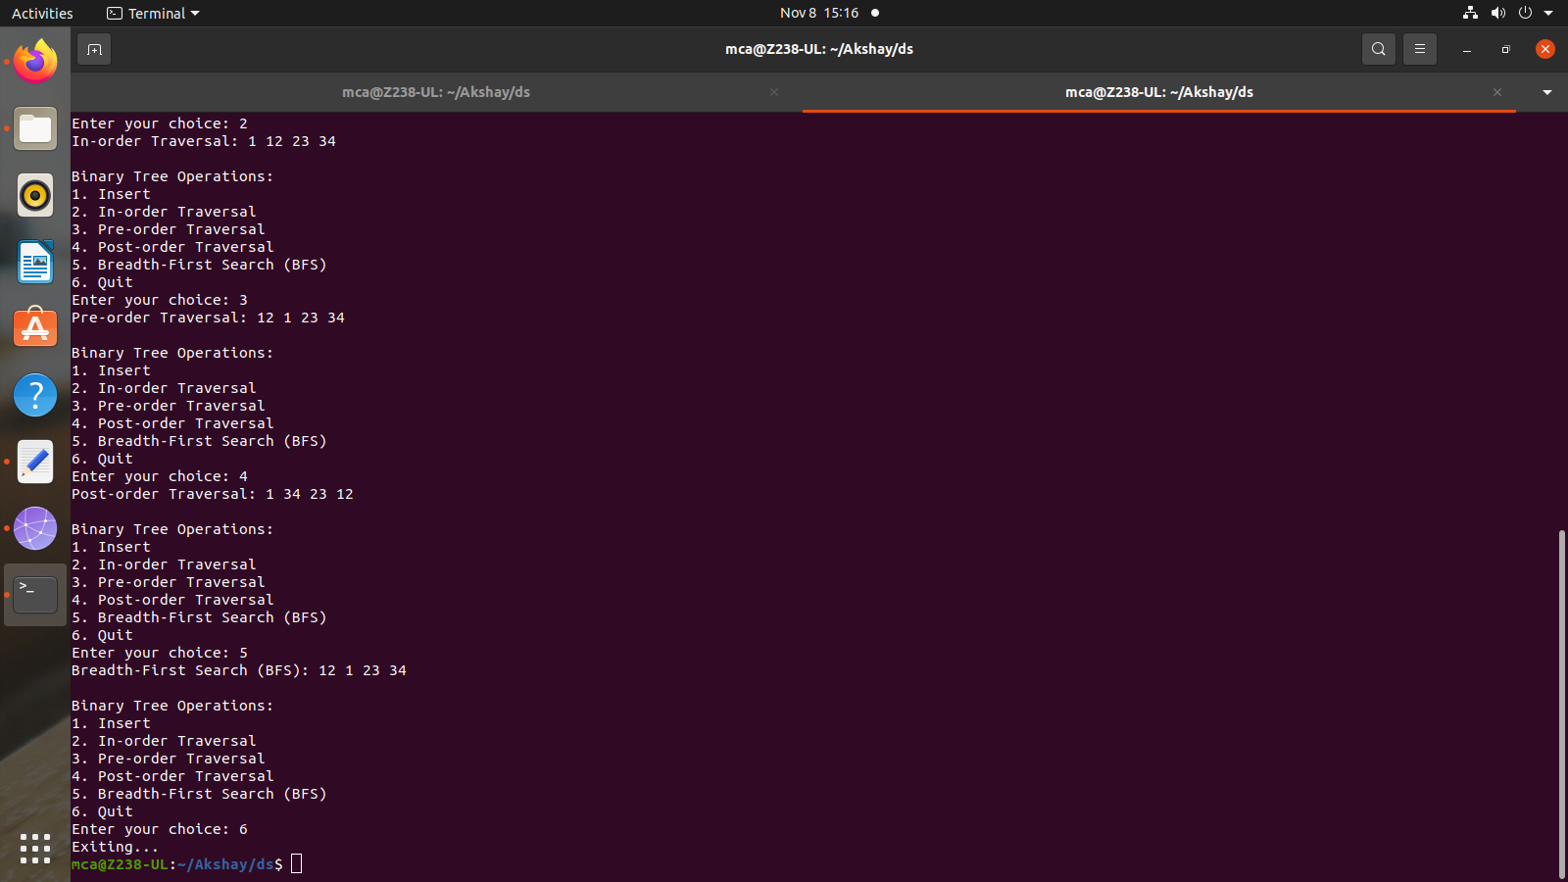

1. **Implement Binomial Heaps and operations (Create, Insert, Delete)**

**Program:**

#include<stdio.h>

#include<malloc.h>

struct node {

int n;

int degree;

struct node* parent;

struct node* child;

struct node* sibling;

};

struct node* MAKE_bin_HEAP();

int bin_LINK(struct node*, struct node*);

struct node* CREATE_NODE(int);

struct node* bin_HEAP_UNION(struct node*, struct node*);

struct node* bin_HEAP_INSERT(struct node*, struct node*);

struct node* bin_HEAP_MERGE(struct node*, struct node*);

struct node* bin_HEAP_EXTRACT_MIN(struct node*);

int REVERT_LIST(struct node*);

int DISPLAY(struct node*);

struct node* FIND_NODE(struct node*, int);

int bin_HEAP_DECREASE_KEY(struct node*, int, int);

int bin_HEAP_DELETE(struct node*, int);

int count = 1;

struct node* MAKE_bin_HEAP() {

struct node* np;

np = NULL;

return np;

}

struct node * H = NULL;

struct node *Hr = NULL;

int bin_LINK(struct node* y, struct node* z) {

y->parent = z;

y->sibling = z->child;

z->child = y;

z->degree = z->degree + 1;

}

struct node* CREATE_NODE(int k) {

struct node* p;//new node;

p = (struct node*) malloc(sizeof(struct node));

p->n = k;

return p;

}

struct node* bin_HEAP_UNION(struct node* H1, struct node* H2) {

struct node* prev_x;

struct node* next_x;

struct node* x;

struct node* H = MAKE_bin_HEAP();

H = bin_HEAP_MERGE(H1, H2);

if (H == NULL)

return H;

prev_x = NULL;

x = H;

next_x = x->sibling;

while (next_x != NULL) {

if ((x->degree != next_x->degree) || ((next_x->sibling != NULL)&& (next_x->sibling)->degree == x->degree)) {

prev_x = x;

x = next_x;

} else {

if (x->n <= next_x->n) {

x->sibling = next_x->sibling;

bin_LINK(next_x, x);

} else {

if (prev_x == NULL)

H = next_x;

else

prev_x->sibling = next_x;

bin_LINK(x, next_x);

x = next_x;

}

}

next_x = x->sibling;}

return H;

}

struct node* bin_HEAP_INSERT(struct node* H, struct node* x) {

struct node* H1 = MAKE_bin_HEAP();

x->parent = NULL;

x->child = NULL;

x->sibling = NULL;

x->degree = 0;

H1 = x;

H = bin_HEAP_UNION(H, H1);

return H;

}

struct node* bin_HEAP_MERGE(struct node* H1, struct node* H2) {

struct node* H = MAKE_bin_HEAP();

struct node* y;

struct node* z;

struct node* a;

struct node* b;

y = H1;

z = H2;

if (y != NULL) {

if (z != NULL && y->degree <= z->degree)

H = y;

else if (z != NULL && y->degree > z->degree)

H = z;

else

H = y;

} else

H = z;

while (y != NULL && z != NULL) {

if (y->degree < z->degree) {

y = y->sibling;

} else if (y->degree == z->degree) {

a = y->sibling;

y->sibling = z;

y = a;

} else {

b = z->sibling;

z->sibling = y;

z = b;

}

}

return H;

}

int DISPLAY(struct node* H) {

struct node* p;

if (H == NULL) {

printf("\nHEAP EMPTY");

return 0;

}

printf("\nTHE ROOT NODES ARE:-\n");

p = H;

while (p != NULL) {

printf("%d", p->n);

if (p->sibling != NULL)

printf("-->");

p = p->sibling;

}

printf("\n");

}

struct node* bin_HEAP_EXTRACT_MIN(struct node* H1) {

int min;

struct node* t = NULL;

struct node* x = H1;

struct node *Hr;

struct node* p;

Hr = NULL;

if (x == NULL) {

printf("\nNOTHING TO EXTRACT");

return x;

}

// int min=x->n;

p = x;

while (p->sibling != NULL) {

if ((p->sibling)->n < min) {

min = (p->sibling)->n;

t = p;

x = p->sibling;

}

p = p->sibling;

}

if (t == NULL && x->sibling == NULL)

H1 = NULL;

else if (t == NULL)

H1 = x->sibling;

else if (t->sibling == NULL)

t = NULL;

else

t->sibling = x->sibling;

if (x->child != NULL) {

REVERT_LIST(x->child);

(x->child)->sibling = NULL;

}

H = bin_HEAP_UNION(H1, Hr);

return x;

}

int REVERT_LIST(struct node* y) {

if (y->sibling != NULL) {

REVERT_LIST(y->sibling);

(y->sibling)->sibling = y;

} else {

Hr = y;

}

}

struct node* FIND_NODE(struct node* H, int k) {

struct node* x = H;

struct node* p = NULL;

if (x->n == k) {

p = x;

return p;

}

if (x->child != NULL && p == NULL) {

p = FIND_NODE(x->child, k);

}

if (x->sibling != NULL && p == NULL) {

p = FIND_NODE(x->sibling, k);

}

return p;

}

int bin_HEAP_DECREASE_KEY(struct node* H, int i, int k) {

int temp;

struct node* p;

struct node* y;

struct node* z;

p = FIND_NODE(H, i);

if (p == NULL) {

printf("\nINVALID CHOICE OF KEY TO BE REDUCED");

return 0;

}

if (k > p->n) {

printf("\nSORY!THE NEW KEY IS GREATER THAN CURRENT ONE");

return 0;

}

p->n = k;

y = p;

z = p->parent;

while (z != NULL && y->n < z->n) {

temp = y->n;

y->n = z->n;

z->n = temp;

y = z;

z = z->parent;

}

printf("\nKEY REDUCED SUCCESSFULLY!");

}

int bin_HEAP_DELETE(struct node* H, int k) {

struct node* np;

if (H == NULL) {

printf("\nHEAP EMPTY");

return 0;

}

bin_HEAP_DECREASE_KEY(H, k, -1000);

np = bin_HEAP_EXTRACT_MIN(H);

if (np != NULL)

printf("\nNODE DELETED SUCCESSFULLY");

}

int main() {

int i, n, m, l;

struct node* p;

struct node* np;

char ch;

printf("\nENTER THE NUMBER OF ELEMENTS:");

scanf("%d", &n);

printf("\nENTER THE ELEMENTS:\n");

for (i = 1; i <= n; i++) {

scanf("%d", &m);

np = CREATE_NODE(m);

H = bin_HEAP_INSERT(H, np);

}

DISPLAY(H);

do {

printf("\nMENU:-\n");

printf(

"\n1)INSERT AN ELEMENT\n2)EXTRACT THE MINIMUM KEY NODE\n3)DECREASE A NODE KEY\n 4)DELETE A NODE\n5)QUIT\n");

scanf("%d", &l);

switch (l) {

case 1:

do {

printf("\nENTER THE ELEMENT TO BE INSERTED:");

scanf("%d", &m);

p = CREATE_NODE(m);

H = bin_HEAP_INSERT(H, p);

printf("\nNOW THE HEAP IS:\n");

DISPLAY(H);

printf("\nINSERT MORE(y/Y)= \n");

fflush(stdin);

scanf("%c", &ch);

} while (ch == 'Y' || ch == 'y');

break;

case 2:

do {

printf("\nEXTRACTING THE MINIMUM KEY NODE");

p = bin_HEAP_EXTRACT_MIN(H);

if (p != NULL)

printf("\nTHE EXTRACTED NODE IS %d", p->n);

printf("\nNOW THE HEAP IS:\n");

DISPLAY(H);

printf("\nEXTRACT MORE(y/Y)\n");

fflush(stdin);

scanf("%c", &ch);

} while (ch == 'Y' || ch == 'y');

break;

case 3:

do {

printf("\nENTER THE KEY OF THE NODE TO BE DECREASED:");

scanf("%d", &m);

printf("\nENTER THE NEW KEY : ");

scanf("%d", &l);

bin_HEAP_DECREASE_KEY(H, m, l);

printf("\nNOW THE HEAP IS:\n");

DISPLAY(H);

printf("\nDECREASE MORE(y/Y)\n");

fflush(stdin);

scanf("%c", &ch);

} while (ch == 'Y' || ch == 'y');

break;

case 4:

do {

printf("\nENTER THE KEY TO BE DELETED: ");

scanf("%d", &m);

bin_HEAP_DELETE(H, m);

printf("\nDELETE MORE(y/Y)\n");

fflush(stdin);

scanf("%c", &ch);

} while (ch == 'y' || ch == 'Y');

break;

case 5:

printf("\nExit\n");

break;

default:

printf("\nINVALID ENTRY...TRY AGAIN....\n");

}

} while (l != 5);

}

**Output:**

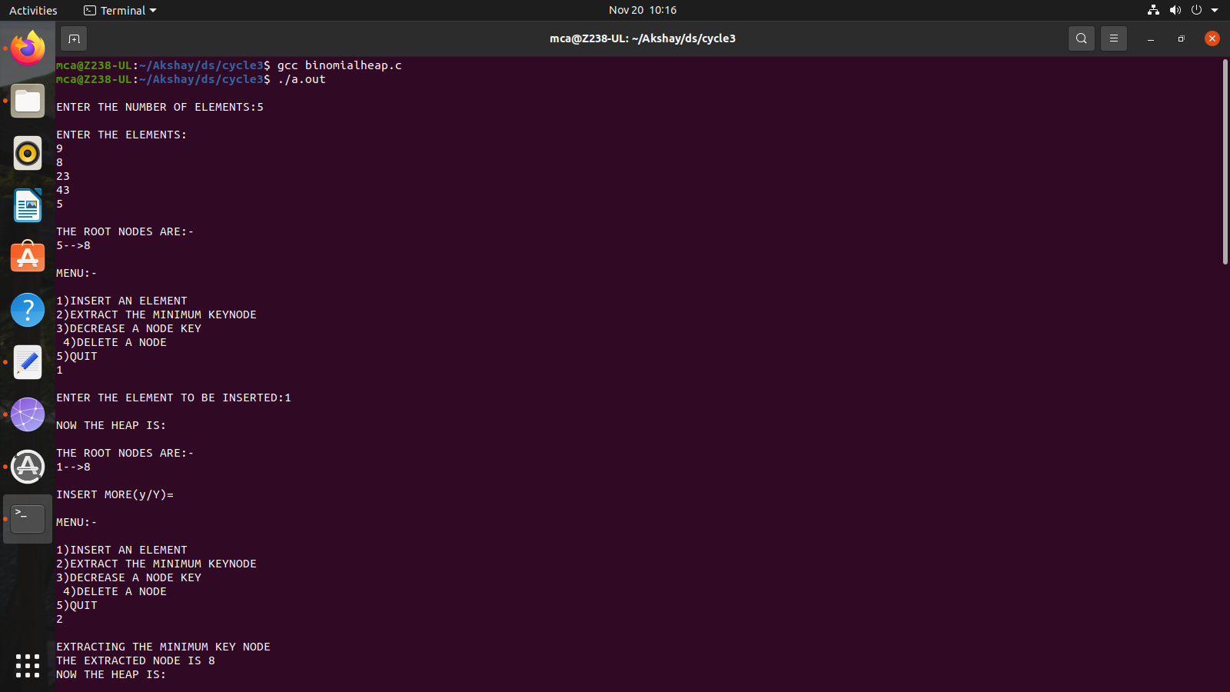

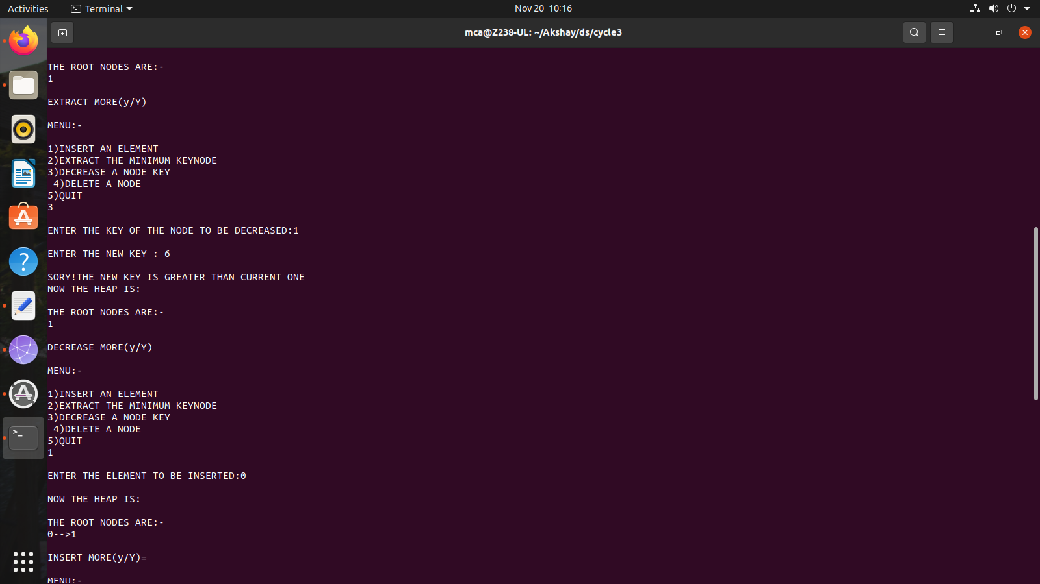

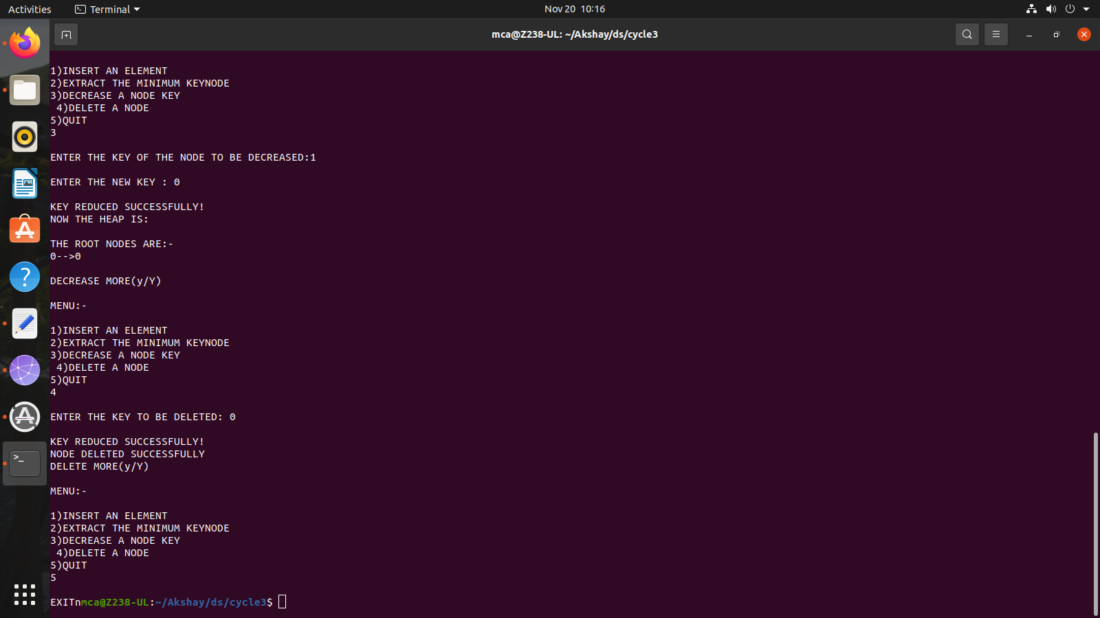

1. **Implement B Trees and its operations**

**Program:**

#include <stdio.h>

#include <stdlib.h>

#define MAX 4

#define MIN 2

struct btreeNode

{

int val[MAX + 1], count;

struct btreeNode *link[MAX + 1];

};

struct btreeNode *root;

/* creating new node */

struct btreeNode * createNode(int val, struct btreeNode *child)

{

struct btreeNode *newNode;

newNode = (struct btreeNode *)malloc(sizeof(struct btreeNode));

newNode->val[1] = val;

newNode->count = 1;

newNode->link[0] = root;

newNode->link[1] = child;

return newNode;

}

/* Places the value in appropriate position */

void addValToNode(int val, int pos, struct btreeNode *node,

struct btreeNode *child)

{

int j = node->count;

while (j > pos)

{

node->val[j + 1] = node->val[j];

node->link[j + 1] = node->link[j];

j--;

}

node->val[j + 1] = val;

node->link[j + 1] = child;

node->count++;

}

/* split the node */

void splitNode (int val, int *pval, int pos, struct btreeNode *node,

struct btreeNode *child, struct btreeNode **newNode)

{

int median, j;

if (pos > MIN)

median = MIN + 1;

else

median = MIN;

*newNode = (struct btreeNode *)malloc(sizeof(struct btreeNode));

j = median + 1;

while (j <= MAX)

{

(*newNode)->val[j - median] = node->val[j];

(*newNode)->link[j - median] = node->link[j];

j++;

}

node->count = median;

(*newNode)->count = MAX - median;

if (pos <= MIN)

{

addValToNode(val, pos, node, child);

}

else

{

addValToNode(val, pos - median, *newNode, child);

}

*pval = node->val[node->count];

(*newNode)->link[0] = node->link[node->count];

node->count--;

}

/* sets the value val in the node */

int setValueInNode(int val, int *pval,

struct btreeNode *node, struct btreeNode **child)

{

int pos;

if (!node)

{

*pval = val;

*child = NULL;

return 1;

}

if (val < node->val[1])

{

pos = 0;

}

else

{

for (pos = node->count;

(val < node->val[pos] && pos > 1); pos--);

if (val == node->val[pos])

{

printf("Duplicates not allowed\n");

return 0;

}

}

if (setValueInNode(val, pval, node->link[pos], child))

{

if (node->count < MAX)

{

addValToNode(*pval, pos, node, *child);

} else

{

splitNode(*pval, pval, pos, node, *child, child);

return 1;

}

}

return 0;

}

/* insert val in B-Tree */

void insertion(int val)

{

int flag, i;

struct btreeNode *child;

flag = setValueInNode(val, &i, root, &child);

if (flag)

root = createNode(i, child);

}

/* copy successor for the value to be deleted */

void copySuccessor(struct btreeNode *myNode, int pos)

{

struct btreeNode *dummy;

dummy = myNode->link[pos];

for (;dummy->link[0] != NULL;)

dummy = dummy->link[0];

myNode->val[pos] = dummy->val[1];

}

/* removes the value from the given node and rearrange values */

void removeVal(struct btreeNode *myNode, int pos)

{

int i = pos + 1;

while (i <= myNode->count) {

myNode->val[i - 1] = myNode->val[i];

myNode->link[i - 1] = myNode->link[i];

i++;

}

myNode->count--;

}

/* shifts value from parent to right child */

void doRightShift(struct btreeNode *myNode, int pos)

{

struct btreeNode *x = myNode->link[pos];

int j = x->count;

while (j > 0) {

x->val[j + 1] = x->val[j];

x->link[j + 1] = x->link[j];

}

x->val[1] = myNode->val[pos];

x->link[1] = x->link[0];

x->count++;

x = myNode->link[pos - 1];

myNode->val[pos] = x->val[x->count];

myNode->link[pos] = x->link[x->count];

x->count--;

return;

}

/* shifts value from parent to left child */

void doLeftShift(struct btreeNode *myNode, int pos)

{

int j = 1;

struct btreeNode *x = myNode->link[pos - 1];

x->count++;

x->val[x->count] = myNode->val[pos];

x->link[x->count] = myNode->link[pos]->link[0];

x = myNode->link[pos];

myNode->val[pos] = x->val[1];

x->link[0] = x->link[1];

x->count--;

while (j <= x->count) {

x->val[j] = x->val[j + 1];

x->link[j] = x->link[j + 1];

j++;

}

return;

}

/* merge nodes */

void mergeNodes(struct btreeNode *myNode, int pos)

{

int j = 1;

struct btreeNode *x1 = myNode->link[pos], *x2 = myNode->link[pos - 1];

x2->count++;

x2->val[x2->count] = myNode->val[pos];

x2->link[x2->count] = myNode->link[0];

while (j <= x1->count)

{

x2->count++;

x2->val[x2->count] = x1->val[j];

x2->link[x2->count] = x1->link[j];

j++;

}

j = pos;

while (j < myNode->count)

{

myNode->val[j] = myNode->val[j + 1];

myNode->link[j] = myNode->link[j + 1];

j++;

}

myNode->count--;

free(x1);

}

/* adjusts the given node */

void adjustNode(struct btreeNode *myNode, int pos)

{

if (!pos) {

if (myNode->link[1]->count > MIN)

{

doLeftShift(myNode, 1);

} else

{

mergeNodes(myNode, 1);

}

} else

{

if (myNode->count != pos)

{

if(myNode->link[pos - 1]->count > MIN)

{

doRightShift(myNode, pos);

} else

{

if (myNode->link[pos + 1]->count > MIN)

{

doLeftShift(myNode, pos + 1);

} else

{

mergeNodes(myNode, pos);

}

}

} else

{

if (myNode->link[pos - 1]->count > MIN)

doRightShift(myNode, pos);

else

mergeNodes(myNode, pos);

}

}

}

/* delete val from the node */

int delValFromNode(int val, struct btreeNode *myNode)

{

int pos, flag = 0;

if (myNode) {

if (val < myNode->val[1])

{

pos = 0;

flag = 0;

} else

{

for (pos = myNode->count;

(val < myNode->val[pos] && pos > 1); pos--);

if (val == myNode->val[pos])

{

flag = 1;

}

else

{

flag = 0;

}

}

if (flag)

{

if (myNode->link[pos - 1])

{

copySuccessor(myNode, pos);

flag = delValFromNode(myNode->val[pos], myNode->link[pos]);

if (flag == 0)

{

printf("Given data is not present in B-Tree\n");

}

} else

{

removeVal(myNode, pos);

}

} else

{

flag = delValFromNode(val, myNode->link[pos]);

}

if (myNode->link[pos])

{

if (myNode->link[pos]->count < MIN)

adjustNode(myNode, pos);

}

}

return flag;

}

/* delete val from B-tree */

void deletion(int val, struct btreeNode *myNode)

{

struct btreeNode *tmp;

if (!delValFromNode(val, myNode))

{

printf("Given value is not present in B-Tree\n");

return;

} else

{

if (myNode->count == 0)

{

tmp = myNode;

myNode = myNode->link[0];

free(tmp);

}

}

root = myNode;

return;

}

/* search val in B-Tree */

void searching(int val, int *pos, struct btreeNode *myNode)

{

if (!myNode)

{

return;

}

if (val < myNode->val[1])

{

*pos = 0;

} else

{

for (*pos = myNode->count;

(val < myNode->val[*pos] && *pos > 1); (*pos)--);

if (val == myNode->val[*pos]) {

printf("Given data %d is present in B-Tree", val);

return;

}

}

searching(val, pos, myNode->link[*pos]);

return;

}

/* B-Tree Traversal */

void traversal(struct btreeNode *myNode)

{

int i;

if (myNode)

{

for (i = 0; i < myNode->count; i++)

{

traversal(myNode->link[i]);

printf("%d ", myNode->val[i + 1]);

}

traversal(myNode->link[i]);

}

}

int main()

{

int val, ch;

while (1)

{

printf("\n1. Insertion\n2. Deletion\n3. Searching\n4. Traversal\n5. Exit\nEnter your choice:\n");

scanf("%d", &ch);

switch (ch)

{

case 1:

printf("Enter your element:");

scanf("%d", &val);

insertion(val);

break;

case 2:

printf("Enter the element to delete:");

scanf("%d", &val);

deletion(val, root);

break;

case 3:

printf("Enter the element to search:");

scanf("%d", &val);

searching(val, &ch, root);

break;

case 4:

traversal(root);

break;

case 5:

exit(0);

default:

printf("U have entered wrong option!!\n");

break;

}

printf("\n");

}

}

**Output:**

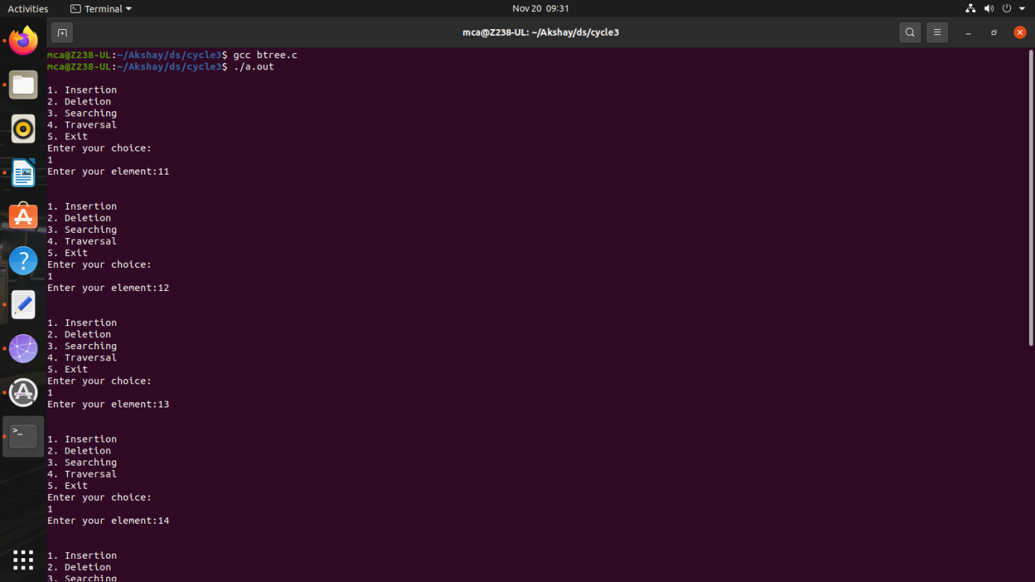

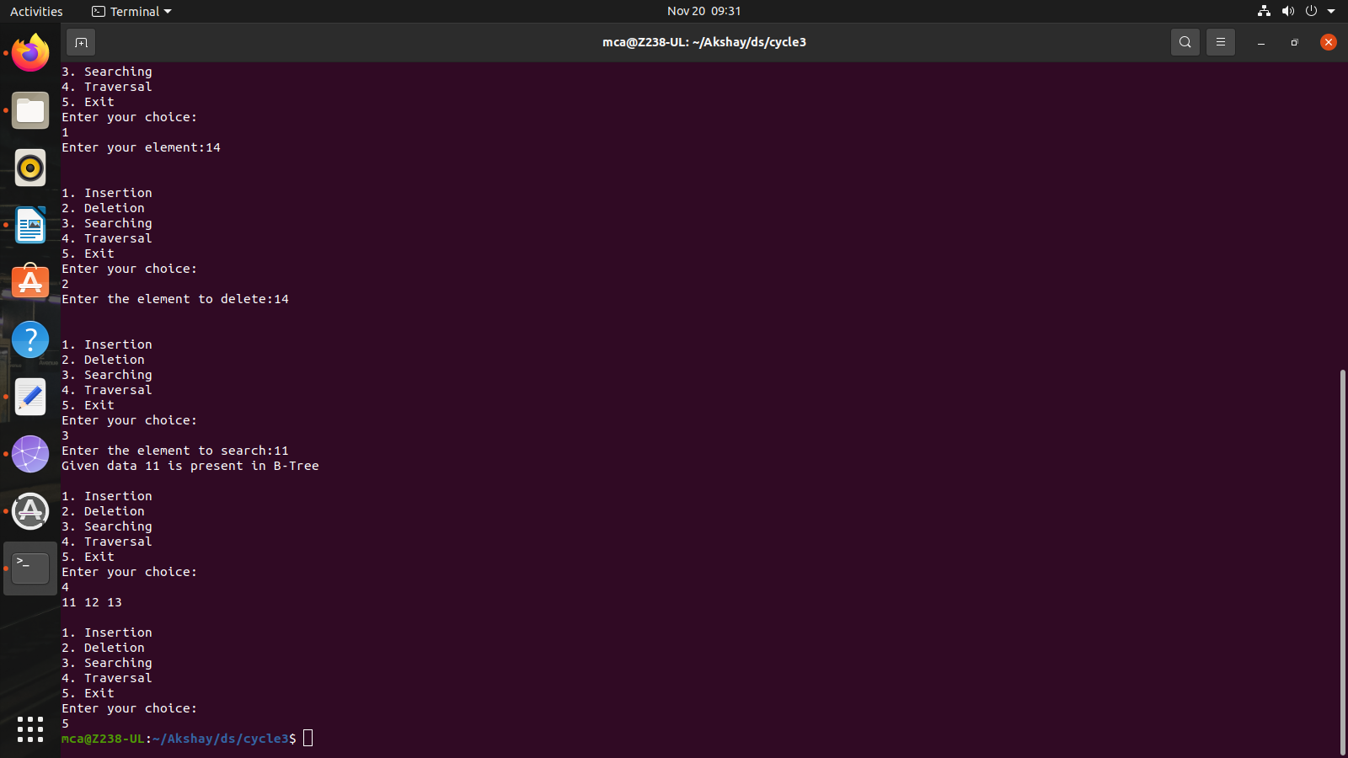

1. **Implement Red Black Trees and its operations**

**Program:**

#include <stdio.h>

#include <stdlib.h>

// Node structure for Red-Black Tree

typedef struct Node {

int key;

int color; // 0 for black, 1 for red

struct Node* parent;

struct Node* left;

struct Node* right;

} Node;

// Sentinel node to represent NULL (external nodes in the tree)

Node* NIL;

// Function to create a new node with given key and color

Node* createNode(int key, int color) {

Node* newNode = (Node*)malloc(sizeof(Node));

newNode->key = key;

newNode->color = color;

newNode->parent = NIL;

newNode->left = NIL;

newNode->right = NIL;

return newNode;

}

// Function to perform left rotation on the given node

void leftRotate(Node** root, Node* x) {

Node* y = x->right;

x->right = y->left;

if (y->left != NIL)

y->left->parent = x;

y->parent = x->parent;

if (x->parent == NIL)

*root = y;

else if (x == x->parent->left)

x->parent->left = y;

else

x->parent->right = y;

y->left = x;

x->parent = y;

}

// Function to perform right rotation on the given node

void rightRotate(Node** root, Node* y) {

Node* x = y->left;

y->left = x->right;

if (x->right != NIL)

x->right->parent = y;

x->parent = y->parent;

if (y->parent == NIL)

*root = x;

else if (y == y->parent->left)

y->parent->left = x;

else

y->parent->right = x;

x->right = y;

y->parent = x;

}

// Function to fix the Red-Black Tree after insertion

void insertFixup(Node** root, Node* z) {

while (z->parent->color == 1) {

if (z->parent == z->parent->parent->left) {

Node* y = z->parent->parent->right;

if (y->color == 1) {

z->parent->color = 0;

y->color = 0;

z->parent->parent->color = 1;

z = z->parent->parent;

} else {

if (z == z->parent->right) {

z = z->parent;

leftRotate(root, z);

}

z->parent->color = 0;

z->parent->parent->color = 1;

rightRotate(root, z->parent->parent);

}

} else {

Node* y = z->parent->parent->left;

if (y->color == 1) {

z->parent->color = 0;

y->color = 0;

z->parent->parent->color = 1;

z = z->parent->parent;

} else {

if (z == z->parent->left) {

z = z->parent;

rightRotate(root, z);

}

z->parent->color = 0;

z->parent->parent->color = 1;

leftRotate(root, z->parent->parent);

}

}

}

(*root)->color = 0;

}

// Function to insert a key into the Red-Black Tree

void insert(Node** root, int key) {

Node* z = createNode(key, 1);

Node* y = NIL;

Node* x = *root;

while (x != NIL) {

y = x;

if (z->key < x->key)

x = x->left;

else

x = x->right;

}

z->parent = y;

if (y == NIL)

*root = z;

else if (z->key < y->key)

y->left = z;

else

y->right = z;

z->left = NIL;

z->right = NIL;

z->color = 1; // Red

insertFixup(root, z);

}

// Function to print the Red-Black Tree (in-order traversal)

void inOrderTraversal(Node* root) {

if (root != NIL) {

inOrderTraversal(root->left);

printf("%d (%s) ", root->key, root->color == 0 ? "Black" : "Red");

inOrderTraversal(root->right);

}

}

int main() {

NIL = createNode(0, 0);

Node* root = NIL;

int choice, key;

do {

printf("\n1. Insert\n2. Display\n3. Exit\n");

printf("Enter your choice: ");

scanf("%d", &choice);

switch (choice) {

case 1:

printf("Enter key to insert: ");

scanf("%d", &key);

insert(&root, key);

break;

case 2:

printf("Red-Black Tree (in-order traversal): \n");

inOrderTraversal(root);

printf("\n");

break;

case 3:

exit(0);

default:

printf("Invalid choice!\n");

}

} while (1);

return 0;

}

**Output:**

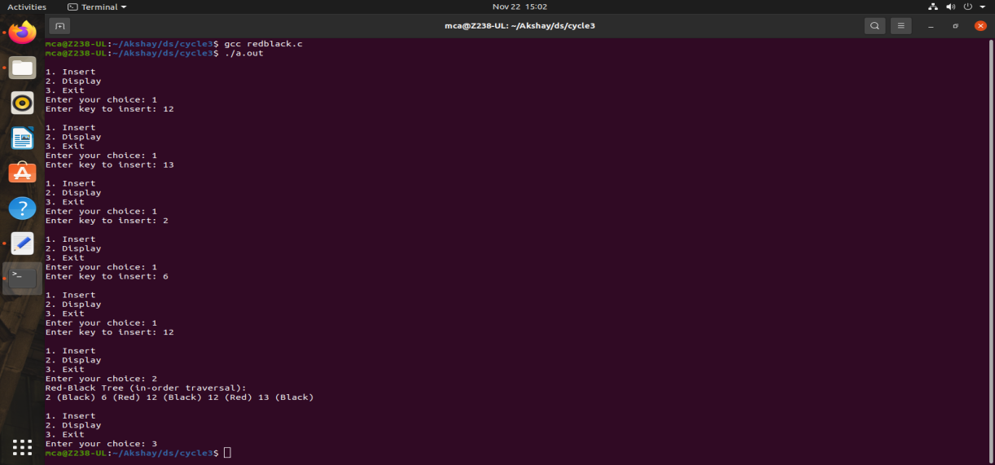

1. **Graph Traversal techniques (DFS and BFS) and Topological Sorting**

**Program:**

#include <stdio.h>

#include <stdlib.h>

#include <stdbool.h>

#define MAX_VERTICES 5

typedef struct Node {

int vertex;

struct Node* next;

} Node;

typedef struct Graph {

Node* adjList[MAX_VERTICES];

int numVertices;

} Graph;

// Function to create a new graph with a given number of vertices

Graph* createGraph(int numVertices) {

if (numVertices <= 0 || numVertices > MAX_VERTICES) {

printf("Invalid number of vertices. Exiting...\n");

exit(EXIT_FAILURE);

}

Graph* graph = (Graph*)malloc(sizeof(Graph));

graph->numVertices = numVertices;

for (int i = 0; i < numVertices; ++i)

graph->adjList[i] = NULL;

return graph;

}

// Function to add an edge to a directed graph

void addEdge(Graph* graph, int src, int dest) {

if (src < 0 || src >= graph->numVertices || dest < 0 || dest >= graph->numVertices) {

printf("Invalid source or destination vertex. Ignoring edge...\n");

return;

}

Node* newNode = (Node*)malloc(sizeof(Node));

newNode->vertex = dest;

newNode->next = graph->adjList[src];

graph->adjList[src] = newNode;

}

// Function to perform Depth-First Search (DFS)

void DFS(Graph* graph, int vertex, bool visited[]) {

visited[vertex] = true;

printf("%d ", vertex);

Node* adjNode = graph->adjList[vertex];

while (adjNode != NULL) {

int adjVertex = adjNode->vertex;

if (!visited[adjVertex])

DFS(graph, adjVertex, visited);

adjNode = adjNode->next;

}

}

// Function to perform Breadth-First Search (BFS)

void BFS(Graph* graph, int start) {

if (start < 0 || start >= graph->numVertices) {

printf("Invalid starting vertex. Exiting...\n");

exit(EXIT_FAILURE);

}

bool visited[MAX_VERTICES] = { false };

int queue[MAX_VERTICES];

int front = 0, rear = -1;

visited[start] = true;

queue[++rear] = start;

while (front <= rear) {

int vertex = queue[front++];

printf("%d ", vertex);

Node* adjNode = graph->adjList[vertex];

while (adjNode != NULL) {

int adjVertex = adjNode->vertex;

if (!visited[adjVertex]) {

visited[adjVertex] = true;

queue[(++rear) % MAX_VERTICES] = adjVertex; // Circular array for the queue

}

adjNode = adjNode->next;

}

}

}

// Function to perform Topological Sorting using DFS

void topologicalSortUtil(Graph* graph, int vertex, bool visited[], int stack[], int* stackIndex) {

visited[vertex] = true;

Node* adjNode = graph->adjList[vertex];

while (adjNode != NULL) {

int adjVertex = adjNode->vertex;

if (!visited[adjVertex])

topologicalSortUtil(graph, adjVertex, visited, stack, stackIndex);

adjNode = adjNode->next;

}

stack[++(*stackIndex)] = vertex;

}

// Function to perform Topological Sorting

void topologicalSort(Graph* graph) {

bool visited[MAX_VERTICES] = { false };

int stack[MAX_VERTICES];

int stackIndex = -1;

for (int i = 0; i < graph->numVertices; ++i) {

if (!visited[i])

topologicalSortUtil(graph, i, visited, stack, &stackIndex);

}

// Print the topological order

printf("Topological Sorting: ");

while (stackIndex >= 0)

printf("%d ", stack[stackIndex--]);

}

int main() {

Graph* graph = createGraph(MAX_VERTICES);

// Pre-define edges for demonstration

addEdge(graph, 0, 1);

addEdge(graph, 0, 3);

addEdge(graph, 1, 2);

addEdge(graph, 2, 3);

addEdge(graph, 3, 4);

int choice;

printf("Choose a technique to demonstrate:\n");

printf("1. DFS\n2. BFS\n3. Topological Sort\n4. Exit\n");

while (1) {

printf("Enter your choice (1-4): ");

scanf("%d", &choice);

switch (choice) {

case 1:

printf("DFS Traversal: ");

DFS(graph, 0, (bool[MAX_VERTICES]){ false });

printf("\n");

break;

case 2:

printf("BFS Traversal: ");

BFS(graph, 0);

printf("\n");

break;

case 3:

topologicalSort(graph);

printf("\n");

break;

case 4:

exit(EXIT_SUCCESS);

default:

printf("Invalid choice!\n");

}

}

return 0;

}

**Output:**

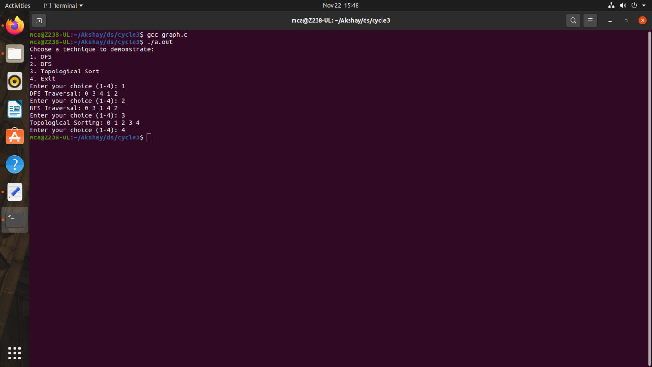

1. **Finding the Strongly connected Components in a directed graph**

**Program:**

#include <stdio.h>

#include <stdlib.h>

#include <stdbool.h>

#define MAX_VERTICES 100

typedef struct Node {

int vertex;

struct Node* next;

} Node;

typedef struct Graph {

Node* adjList[MAX_VERTICES];

Node* revAdjList[MAX_VERTICES];

int numVertices;

} Graph;

Graph* createGraph(int numVertices) {

if (numVertices <= 0 || numVertices > MAX_VERTICES) {

printf("Invalid number of vertices. Exiting...\n");

exit(EXIT_FAILURE);

}

Graph* graph = (Graph*)malloc(sizeof(Graph));

graph->numVertices = numVertices;

for (int i = 0; i < numVertices; ++i) {

graph->adjList[i] = NULL;

graph->revAdjList[i] = NULL;

}

return graph;

}

void addEdge(Graph* graph, int src, int dest) {

if (src < 0 || src >= graph->numVertices || dest < 0 || dest >= graph->numVertices) {

printf("Invalid source or destination vertex. Ignoring edge...\n");

return;

}

Node* newNode = (Node*)malloc(sizeof(Node));

newNode->vertex = dest;

newNode->next = graph->adjList[src];

graph->adjList[src] = newNode;

// Reverse graph for Kosaraju's algorithm

newNode = (Node*)malloc(sizeof(Node));

newNode->vertex = src;

newNode->next = graph->revAdjList[dest];

graph->revAdjList[dest] = newNode;

}

void DFSUtil(Graph* graph, int vertex, bool visited[]) {

visited[vertex] = true;

printf("%d ", vertex);

Node* adjNode = graph->adjList[vertex];

while (adjNode != NULL) {

int adjVertex = adjNode->vertex;

if (!visited[adjVertex])

DFSUtil(graph, adjVertex, visited);

adjNode = adjNode->next;

}

}

void fillOrder(Graph* graph, int vertex, bool visited[], int stack[], int* stackIndex) {

visited[vertex] = true;

Node* adjNode = graph->revAdjList[vertex];

while (adjNode != NULL) {

int adjVertex = adjNode->vertex;

if (!visited[adjVertex])

fillOrder(graph, adjVertex, visited, stack, stackIndex);

adjNode = adjNode->next;

}

stack[++(*stackIndex)] = vertex;

}

Graph* getTranspose(Graph* graph) {

Graph* transposedGraph = createGraph(graph->numVertices);

for (int i = 0; i < graph->numVertices; ++i) {

Node* current = graph->adjList[i];

while (current != NULL) {

addEdge(transposedGraph, current->vertex, i);

current = current->next;

}

}

return transposedGraph;

}

void printSCCs(Graph* graph) {

int stack[MAX_VERTICES];

int stackIndex = -1;

bool visited[MAX_VERTICES] = { false };

for (int i = 0; i < graph->numVertices; ++i) {

if (!visited[i])

fillOrder(graph, i, visited, stack, &stackIndex);

}

Graph* transposedGraph = getTranspose(graph);

for (int i = 0; i < graph->numVertices; ++i)

visited[i] = false;

while (stackIndex >= 0) {

int vertex = stack[stackIndex--];

if (!visited[vertex]) {

DFSUtil(transposedGraph, vertex, visited);

printf("\n");

}

}

free(transposedGraph);

}

int main() {

Graph* graph = createGraph(8);

// Define edges for demonstration

addEdge(graph, 0, 1);

addEdge(graph, 1, 2);

addEdge(graph, 2, 0);

addEdge(graph, 2, 3);

addEdge(graph, 3, 4);

addEdge(graph, 4, 5);

addEdge(graph, 5, 3);

addEdge(graph, 6, 5);

addEdge(graph, 6, 7);

addEdge(graph, 7, 6);

printf("Strongly Connected Components:\n");

printSCCs(graph);

return 0;

}

**Output:**

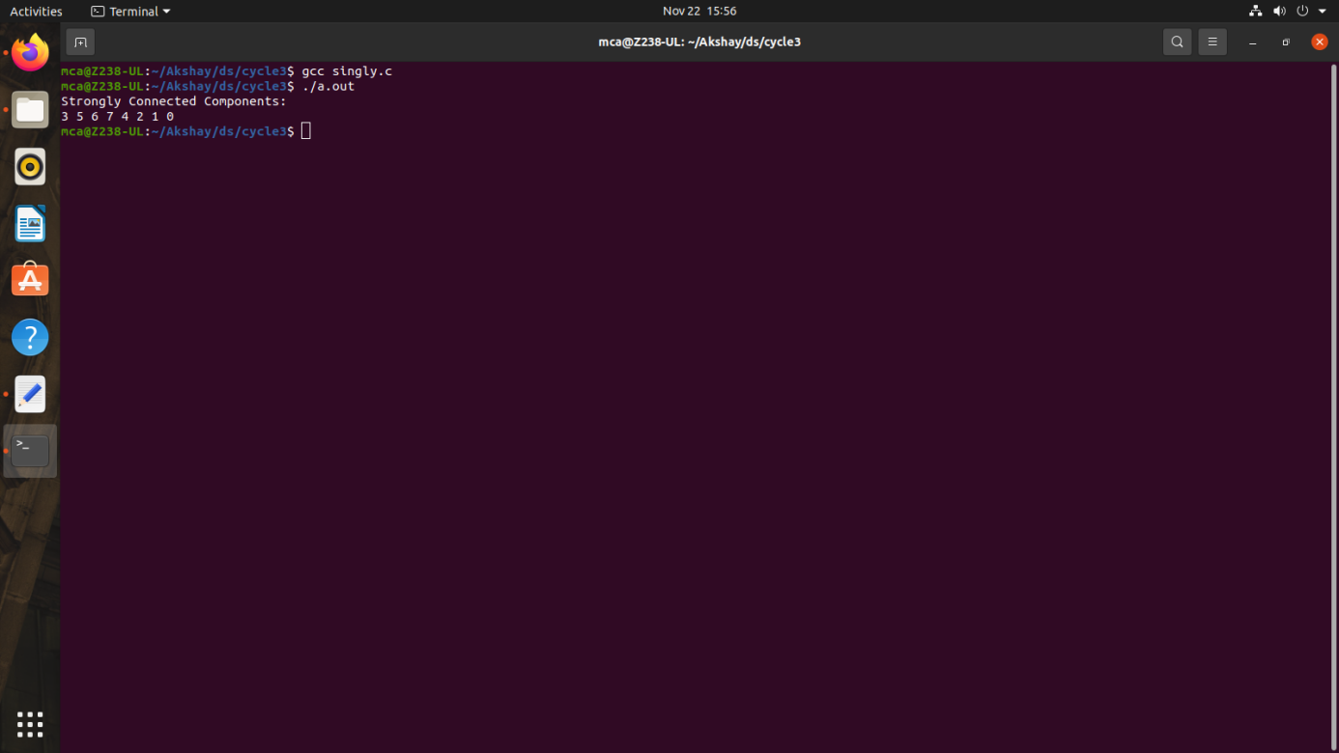

1. **Prim’s Algorithm for finding the minimum cost spanning tree**

**Program:**

#include <stdio.h>

#include <stdlib.h>

#include <stdbool.h>

#define MAX_VERTICES 100

#define INF 999999

typedef struct {

int parent;

int key;

bool inMST;

} Vertex;

typedef struct Graph {

int numVertices;

int adjacencyMatrix[MAX_VERTICES][MAX_VERTICES];

Vertex vertices[MAX_VERTICES];

} Graph;

Graph* createGraph(int numVertices) {

if (numVertices <= 0 || numVertices > MAX_VERTICES) {

printf("Invalid number of vertices. Exiting...\n");

exit(EXIT_FAILURE);

}

Graph* graph = (Graph*)malloc(sizeof(Graph));

graph->numVertices = numVertices;

for (int i = 0; i < numVertices; ++i) {

graph->vertices[i].parent = -1;

graph->vertices[i].key = INF;

graph->vertices[i].inMST = false;

for (int j = 0; j < numVertices; ++j)

graph->adjacencyMatrix[i][j] = INF;

}

return graph;

}

void addEdge(Graph* graph, int src, int dest, int weight) {

if (src >= 0 && src < graph->numVertices && dest >= 0 && dest < graph->numVertices) {

graph->adjacencyMatrix[src][dest] = weight;

graph->adjacencyMatrix[dest][src] = weight;

} else {

printf("Invalid source or destination vertex. Ignoring edge...\n");

}

}

int findMinKeyVertex(Graph* graph) {

int minKey = INF;

int minIndex = -1;

for (int i = 0; i < graph->numVertices; ++i) {

if (!graph->vertices[i].inMST && graph->vertices[i].key < minKey) {

minKey = graph->vertices[i].key;

minIndex = i;

}

}

return minIndex;

}

void primMST(Graph* graph) {

graph->vertices[0].key = 0;

for (int count = 0; count < graph->numVertices - 1; ++count) {

int u = findMinKeyVertex(graph);

graph->vertices[u].inMST = true;

for (int v = 0; v < graph->numVertices; ++v) {

if (graph->adjacencyMatrix[u][v] != INF && !graph->vertices[v].inMST &&

graph->adjacencyMatrix[u][v] < graph->vertices[v].key) {

graph->vertices[v].key = graph->adjacencyMatrix[u][v];

graph->vertices[v].parent = u;

}

}

}

printf("Minimum Cost Spanning Tree (Prim's Algorithm):\n");

for (int i = 1; i < graph->numVertices; ++i)

printf("Edge: %d - %d, Weight: %d\n", graph->vertices[i].parent, i, graph->vertices[i].key);

}

int main() {

Graph* graph = createGraph(5);

// Define edges for demonstration

addEdge(graph, 0, 1, 2);

addEdge(graph, 0, 3, 6);

addEdge(graph, 1, 2, 3);

addEdge(graph, 1, 3, 8);

addEdge(graph, 1, 4, 5);

addEdge(graph, 2, 4, 7);

addEdge(graph, 3, 4, 9);

primMST(graph);

return 0;

}

**Output:**

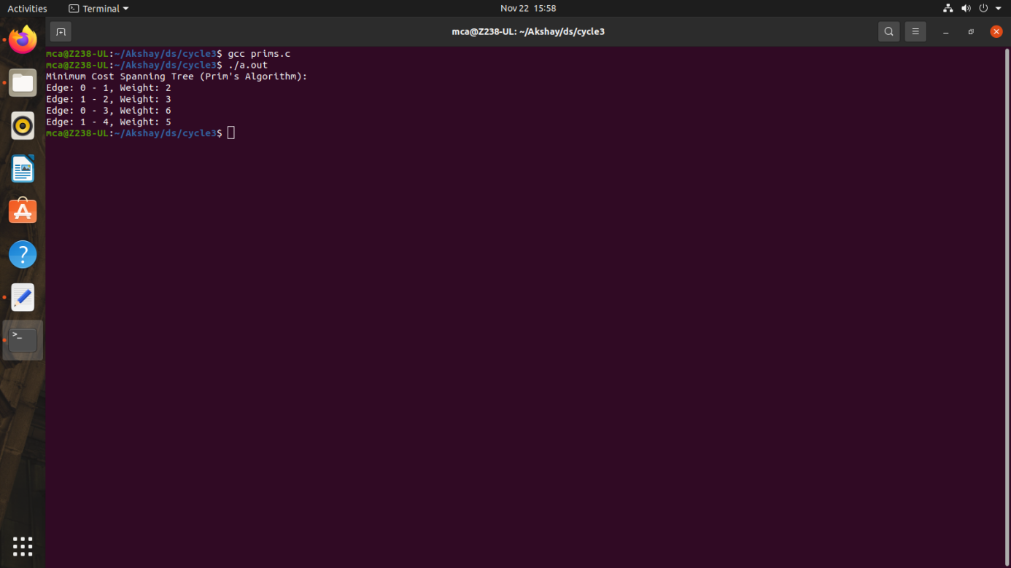

1. **Kruskal’s algorithm using the Disjoint set data structure**

**Program:**

#include <stdio.h>

#include <stdlib.h>

#define MAX_VERTICES 100

typedef struct Edge {

int src, dest, weight;

} Edge;

typedef struct {

int parent, rank;

} Subset;

typedef struct {

int numVertices, numEdges;

Edge edges[MAX_VERTICES * MAX_VERTICES];

} Graph;

Graph* createGraph(int numVertices, int numEdges) {

if (numVertices <= 0 || numVertices > MAX_VERTICES || numEdges <= 0 || numEdges > MAX_VERTICES * MAX_VERTICES) {

printf("Invalid number of vertices or edges. Exiting...\n");

exit(EXIT_FAILURE);

}

Graph* graph = (Graph*)malloc(sizeof(Graph));

graph->numVertices = numVertices;

graph->numEdges = numEdges;

return graph;

}

void addEdge(Graph* graph, int index, int src, int dest, int weight) {

if (index >= 0 && index < graph->numEdges && src >= 0 && src < graph->numVertices &&

dest >= 0 && dest < graph->numVertices) {

graph->edges[index].src = src;

graph->edges[index].dest = dest;

graph->edges[index].weight = weight;

} else {

printf("Invalid edge information. Exiting...\n");

exit(EXIT_FAILURE);

}

}

int compareEdges(const void* a, const void* b) {

return ((Edge*)a)->weight - ((Edge*)b)->weight;

}

int find(Subset subsets[], int i) {

if (subsets[i].parent != i)

subsets[i].parent = find(subsets, subsets[i].parent);

return subsets[i].parent;

}

void unionSets(Subset subsets[], int x, int y) {

int xroot = find(subsets, x);

int yroot = find(subsets, y);

if (subsets[xroot].rank < subsets[yroot].rank)

subsets[xroot].parent = yroot;

else if (subsets[xroot].rank > subsets[yroot].rank)

subsets[yroot].parent = xroot;

else {

subsets[yroot].parent = xroot;

subsets[xroot].rank++;

}

}

void kruskalMST(Graph* graph) {

Edge result[graph->numVertices];

int e = 0;

int i = 0;

qsort(graph->edges, graph->numEdges, sizeof(graph->edges[0]), compareEdges);

Subset subsets[graph->numVertices];

for (i = 0; i < graph->numVertices; ++i) {

subsets[i].parent = i;

subsets[i].rank = 0;

}

i = 0;

while (e < graph->numVertices - 1 && i < graph->numEdges) {

Edge nextEdge = graph->edges[i++];

int x = find(subsets, nextEdge.src);

int y = find(subsets, nextEdge.dest);

if (x != y) {

result[e++] = nextEdge;

unionSets(subsets, x, y);

}

}

printf("Minimum Cost Spanning Tree (Kruskal's Algorithm):\n");

for (i = 0; i < e; ++i)

printf("Edge: %d - %d, Weight: %d\n", result[i].src, result[i].dest, result[i].weight);

}

int main() {

Graph* graph = createGraph(4, 5);

// Define edges for demonstration

addEdge(graph, 0, 0, 1, 10);

addEdge(graph, 1, 0, 2, 6);

addEdge(graph, 2, 0, 3, 5);

addEdge(graph, 3, 1, 3, 15);

addEdge(graph, 4, 2, 3, 4);

kruskalMST(graph);

return 0;

}

**Output:**

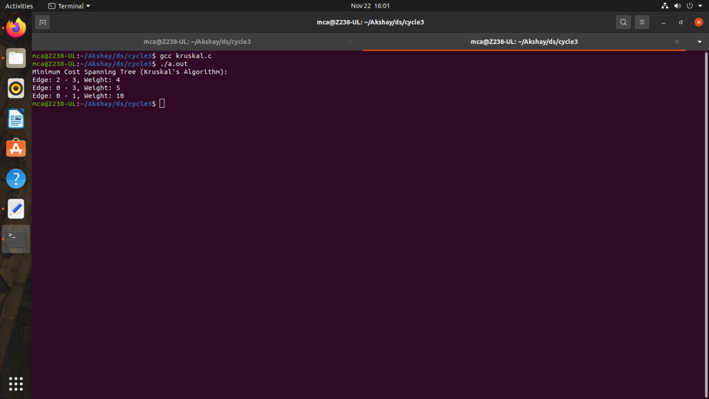

1. **Single Source shortest path algorithm using any heap structure that supports mergeable heap operations**

**Program:**

#include <stdio.h>

#include <stdlib.h>

#include <stdbool.h>

#include <time.h>

#define MAX_VERTICES 5

#define MAX_DISTANCE 50 // Adjust this based on the expected maximum distance between nodes

typedef struct {

int vertex, distance;

} Node;

typedef struct {

Node* heap;

int capacity, size;

} MinHeap;

typedef struct {

int numVertices;

int adjacencyMatrix[MAX_VERTICES][MAX_VERTICES];

} Graph;

Graph* createGraph(int numVertices) {

if (numVertices <= 0 || numVertices > MAX_VERTICES) {

printf("Invalid number of vertices. Exiting...\n");

exit(EXIT_FAILURE);

}

Graph* graph = (Graph*)malloc(sizeof(Graph));

graph->numVertices = numVertices;

for (int i = 0; i < numVertices; ++i) {

for (int j = 0; j < numVertices; ++j) {

if (i == j) {

graph->adjacencyMatrix[i][j] = 0; // Distance from a vertex to itself is 0

} else {

graph->adjacencyMatrix[i][j] = rand() % MAX_DISTANCE + 1; // Random distance between 1 and MAX_DISTANCE

}

}

}

return graph;

}

MinHeap* createMinHeap(int capacity) {

MinHeap* heap = (MinHeap*)malloc(sizeof(MinHeap));

heap->capacity = capacity;

heap->size = 0;

heap->heap = (Node*)malloc(capacity * sizeof(Node));

return heap;

}

void swap(Node* a, Node* b) {

Node temp = *a;

*a = *b;

*b = temp;

}

void minHeapify(MinHeap* heap, int idx) {

int smallest = idx;

int left = 2 * idx + 1;

int right = 2 * idx + 2;

if (left < heap->size && heap->heap[left].distance < heap->heap[smallest].distance)

smallest = left;

if (right < heap->size && heap->heap[right].distance < heap->heap[smallest].distance)

smallest = right;

if (smallest != idx) {

swap(&heap->heap[idx], &heap->heap[smallest]);

minHeapify(heap, smallest);

}

}

bool isEmpty(MinHeap* heap) {

return heap->size == 0;

}

Node extractMin(MinHeap* heap) {

if (isEmpty(heap))

exit(EXIT_FAILURE);

Node root = heap->heap[0];

heap->heap[0] = heap->heap[heap->size - 1];

heap->size--;

minHeapify(heap, 0);

return root;

}

void decreaseKey(MinHeap* heap, int vertex, int distance) {

int i;

for (i = 0; i < heap->size; ++i) {

if (heap->heap[i].vertex == vertex) {

heap->heap[i].distance = distance;

break;

}

}

while (i != 0 && heap->heap[i].distance < heap->heap[(i - 1) / 2].distance) {

swap(&heap->heap[i], &heap->heap[(i - 1) / 2]);

i = (i - 1) / 2;

}

}

void dijkstra(Graph* graph, int src, int dest) {

MinHeap* heap = createMinHeap(graph->numVertices);

Node* result = (Node*)malloc(graph->numVertices * sizeof(Node));

for (int i = 0; i < graph->numVertices; ++i) {

heap->heap[i].vertex = i;

heap->heap[i].distance = MAX_DISTANCE * graph->numVertices + 1; // A value larger than the sum of all possible distances

result[i].vertex = -1;

result[i].distance = MAX_DISTANCE * graph->numVertices + 1;

}

heap->heap[src].distance = 0;

result[src].distance = 0;

clock_t start_time = clock();

while (!isEmpty(heap)) {

Node current = extractMin(heap);

int u = current.vertex;

for (int v = 0; v < graph->numVertices; ++v) {

if (graph->adjacencyMatrix[u][v] != 0) { // Consider only non-zero distances

int alt = result[u].distance + graph->adjacencyMatrix[u][v];

if (alt < result[v].distance) {

result[v].distance = alt;

result[v].vertex = u;

decreaseKey(heap, v, alt);

}

}

}

}

clock_t end_time = clock();

double execution_time = ((double)(end_time - start_time)) / CLOCKS_PER_SEC;

printf("Paths from source %d to destination %d:\n", src, dest);

printf("Shortest Distance: %d\n", result[dest].distance);

printf("Execution Time: %f seconds\n", execution_time);

printf("Path: ");

int temp = dest;

while (temp != -1) {

printf("%d ", temp);

temp = result[temp].vertex;

}

printf("\n");

printf("All Paths Traversed:\n");

for (int i = 0; i < graph->numVertices; ++i) {

if (i == src) continue;

printf("To vertex %d: Distance = %d, Path = ", i, result[i].distance);

temp = i;

while (temp != -1) {

printf("%d ", temp);

temp = result[temp].vertex;

}

printf("\n");

}

free(heap->heap);

free(heap);

free(result);

}

int main() {

srand(time(NULL));

Graph* graph = createGraph(5);

printf("Random Distance Matrix:\n");

for (int i = 0; i < graph->numVertices; ++i) {

for (int j = 0; j < graph->numVertices; ++j) {

printf("%2d ", graph->adjacencyMatrix[i][j]);

}

printf("\n");

}

int sourceVertex, destVertex;

printf("\nEnter source vertex (0-%d): ", graph->numVertices - 1);

scanf("%d", &sourceVertex);

printf("Enter destination vertex (0-%d): ", graph->numVertices - 1);

scanf("%d", &destVertex);

if (sourceVertex < 0 || sourceVertex >= graph->numVertices ||

destVertex < 0 || destVertex >= graph->numVertices) {

printf("Invalid source or destination vertex. Exiting...\n");

return EXIT_FAILURE;

}

dijkstra(graph, sourceVertex, destVertex);

free(graph);

return 0;

}

**Output:**

